**ER DIAGRAM (BASED ON THE TABLES PROVIDED)**

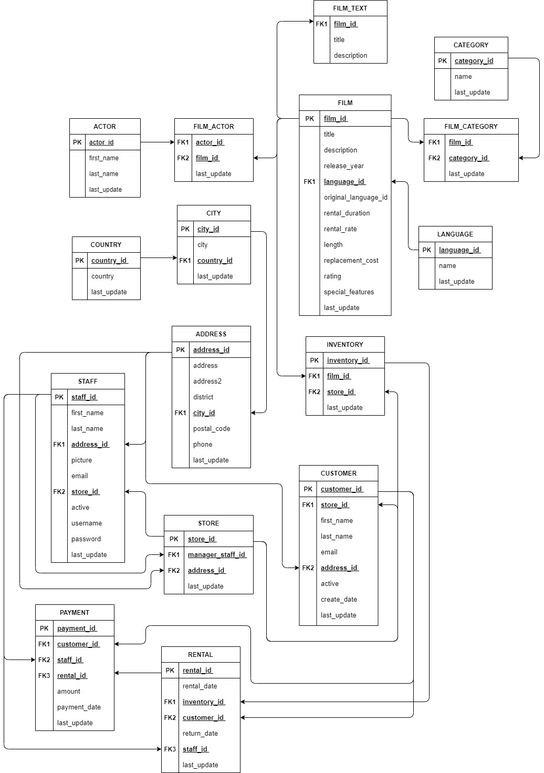

**CREATION OF DATABASE ‘ENTERTAINMENT’**

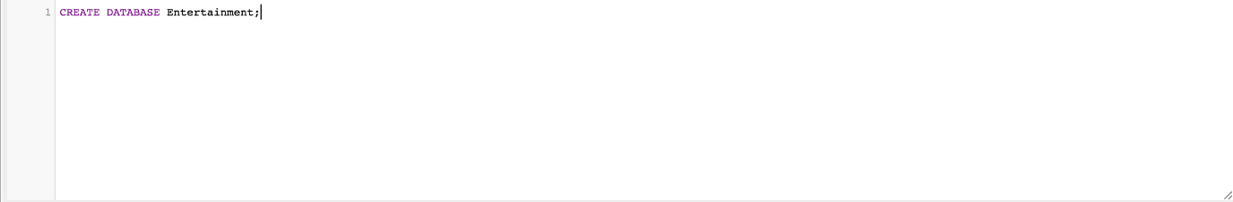

**CREATION AND INSERTION OF TABLES**

* **TABLE ‘ACTOR’**

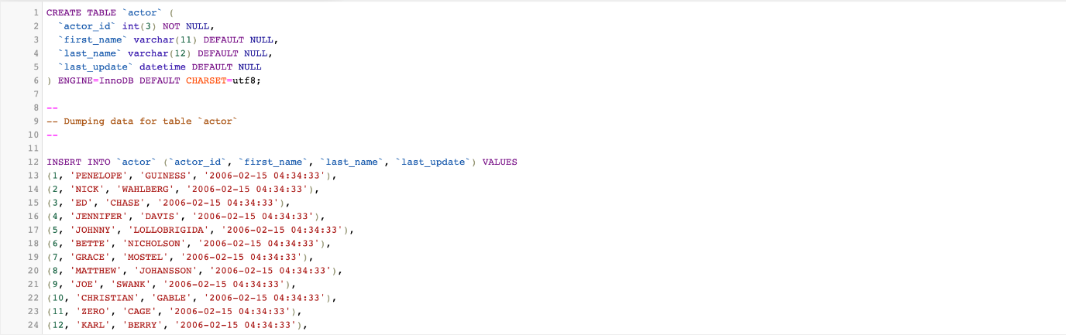

* **TABLE ‘ADDRESS’**

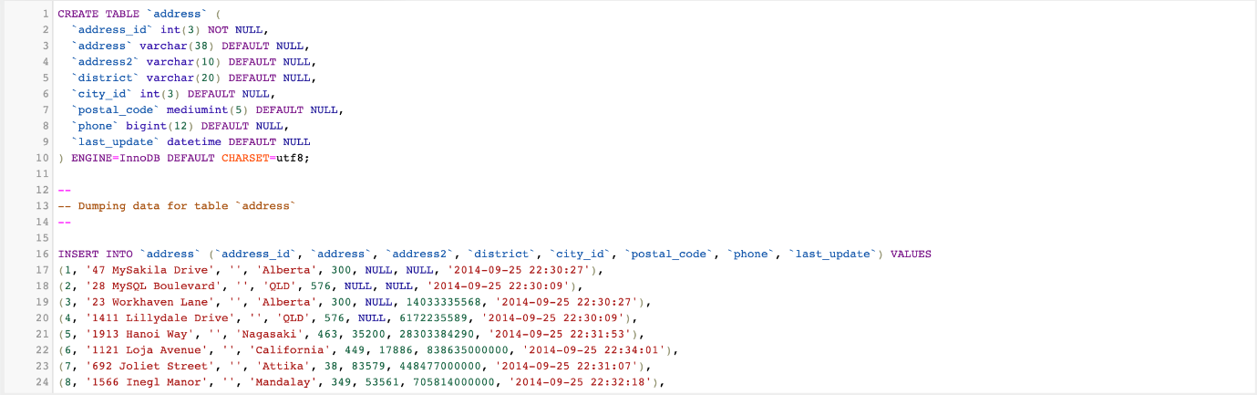

* **TABLE ‘CATEGORY’**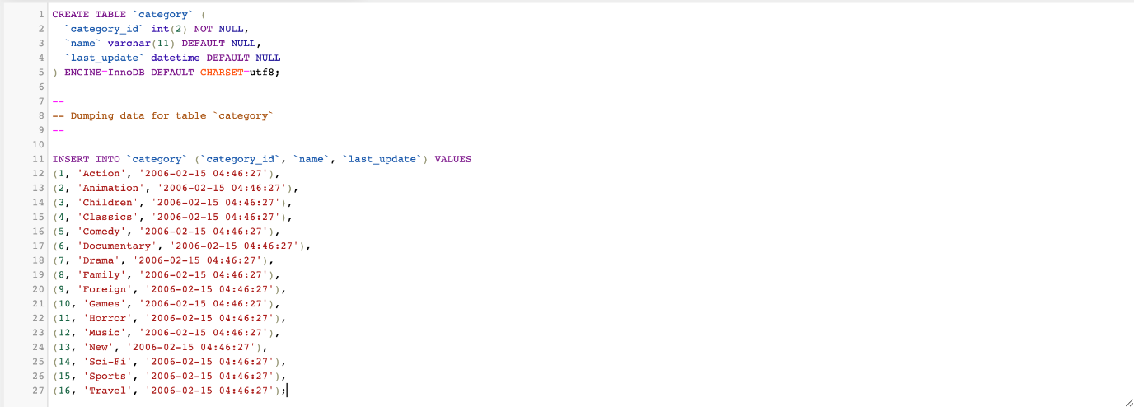
* **TABLE 'CITY’**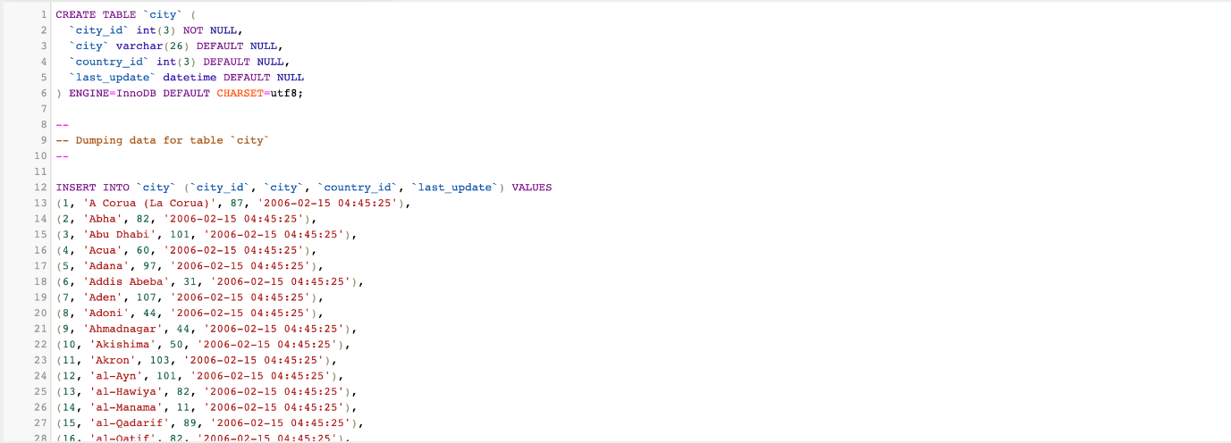
* **TABLE 'COUNTRY’**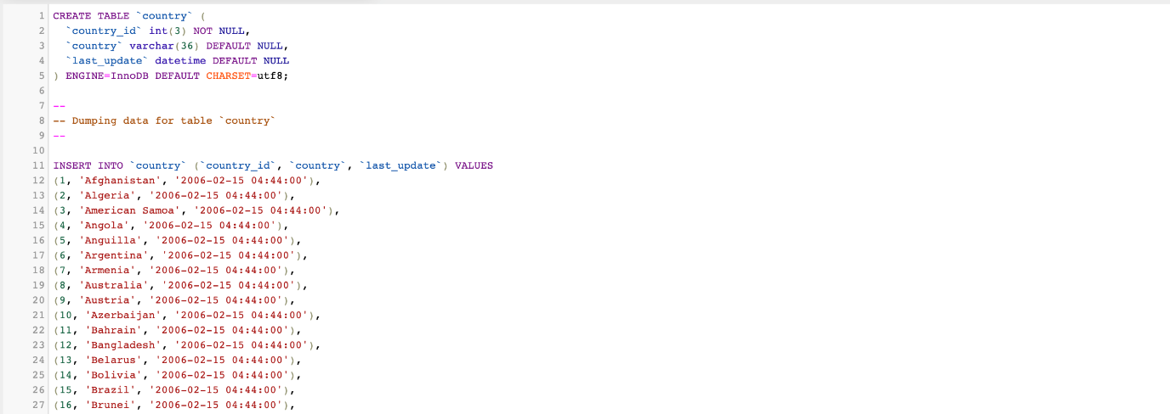
* **TABLE 'CUSTOMER’**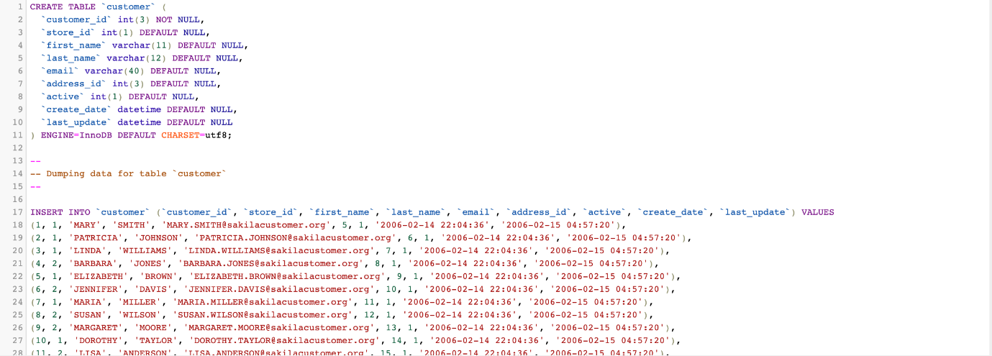
* **TABLE 'FILM’**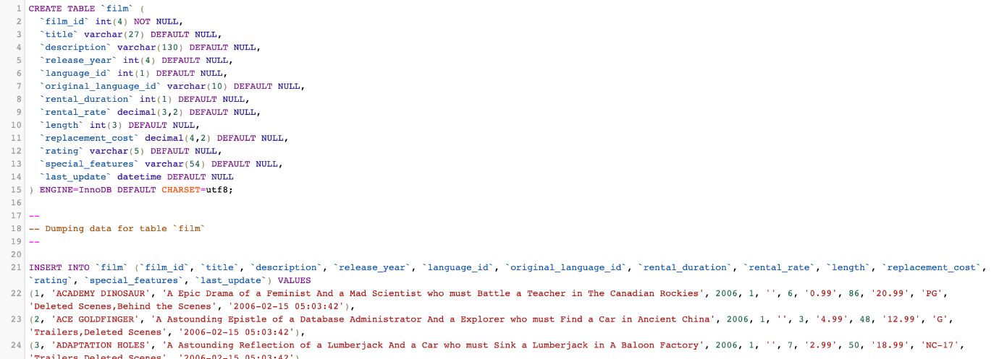
* **TABLE 'FILM_ACTOR’**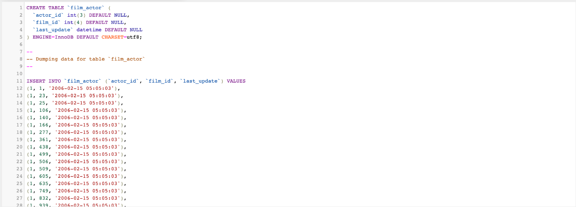
* **TABLE 'FILM_CATEGORY’**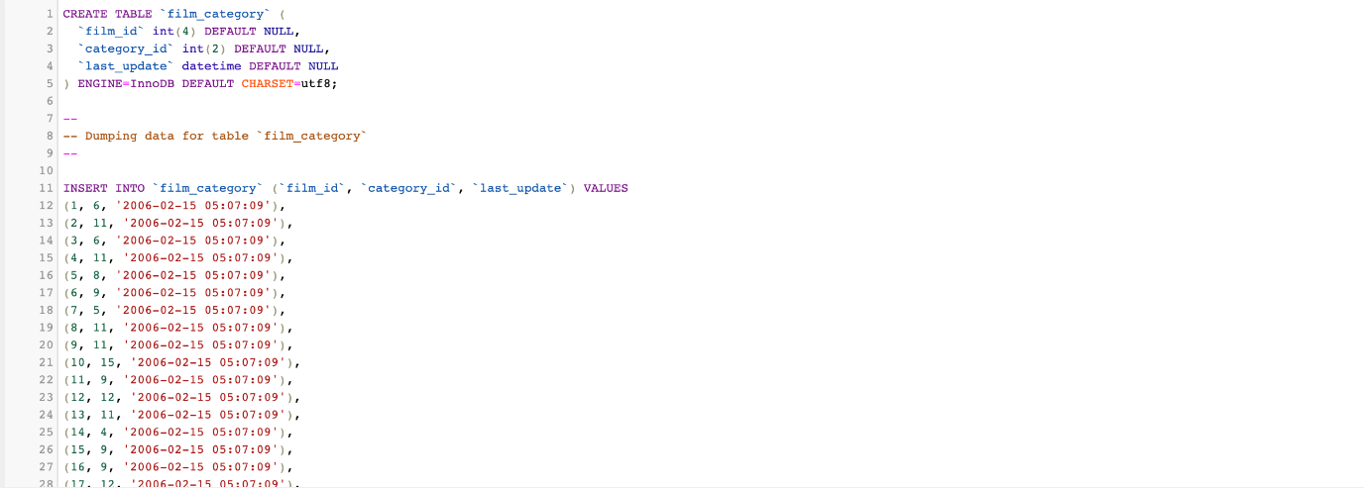
* **TABLE 'FILM_TEXT’**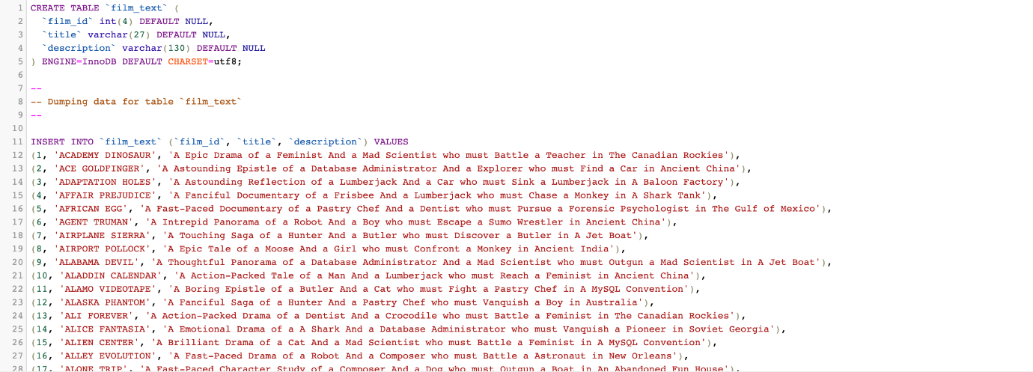
* **TABLE 'INVENTORY’** 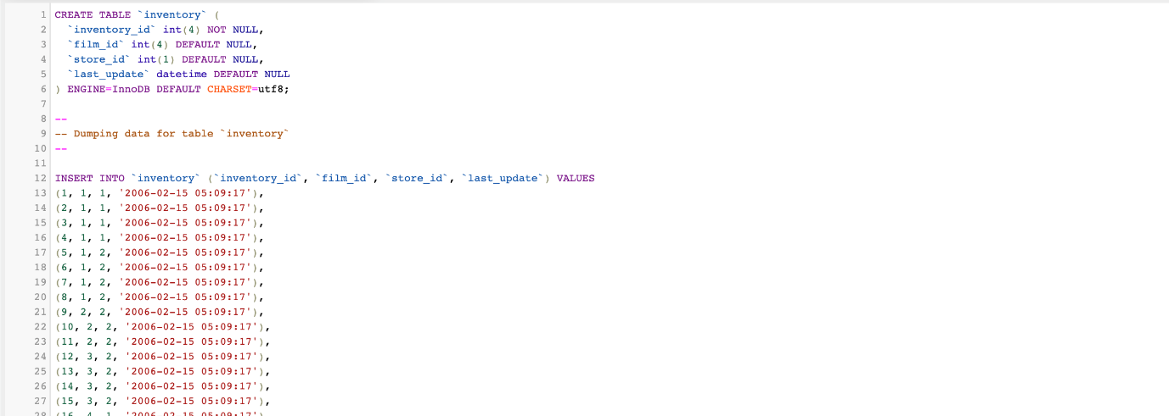
* **TABLE 'LANGUAGE’** 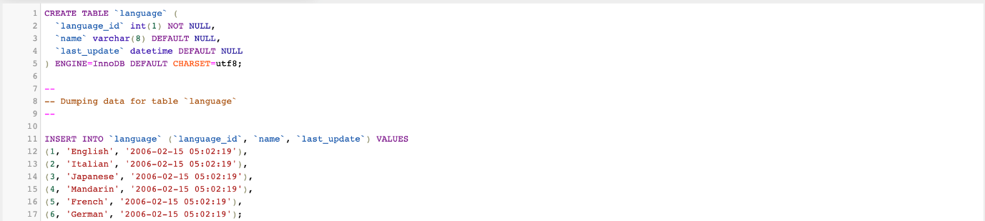
* **TABLE 'PAYMENT’** 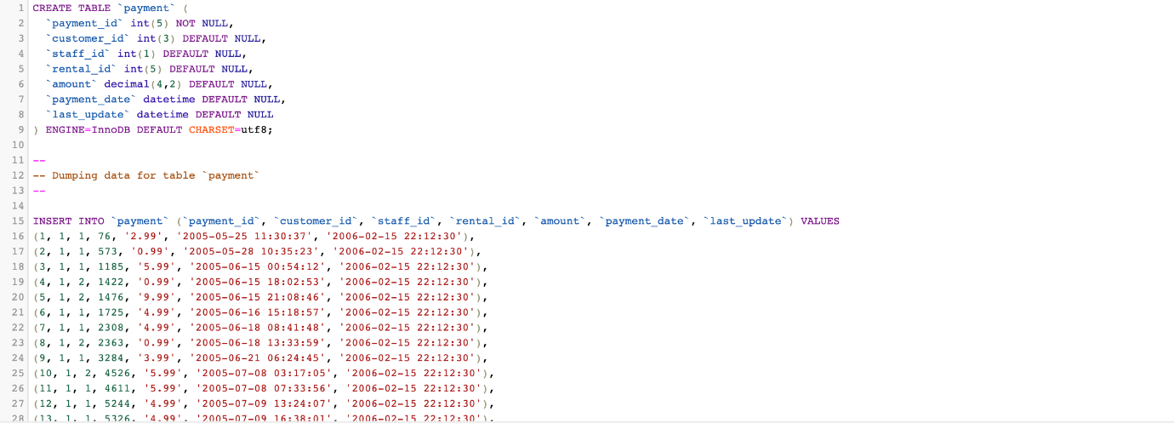
* **TABLE 'RENTAL’** 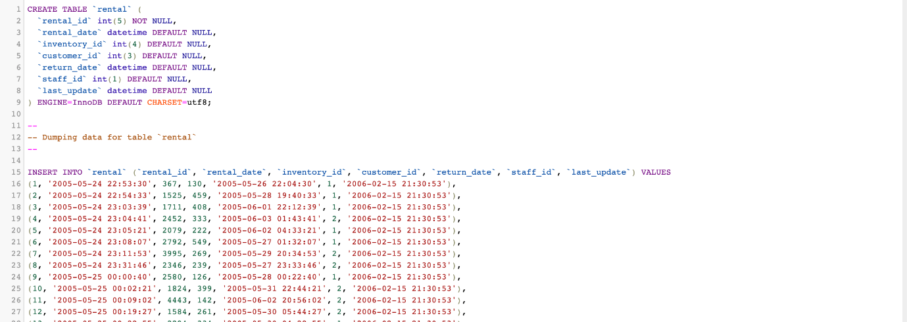
* **TABLE 'STAFF’** 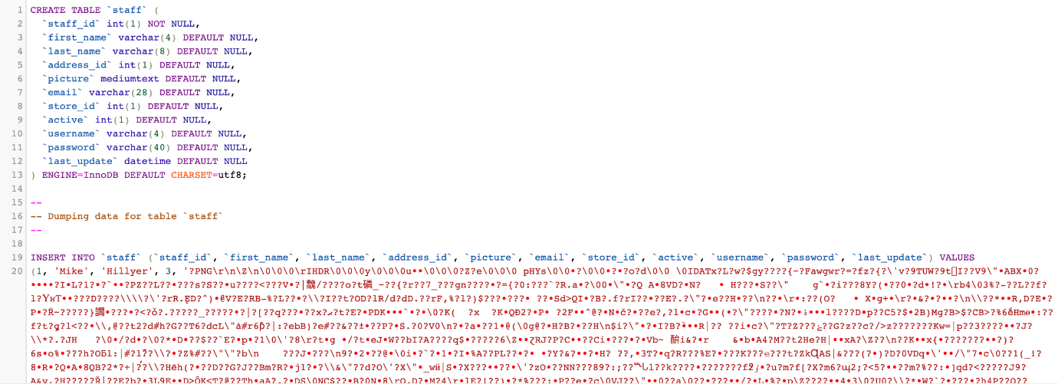
* **TABLE 'STORE’** 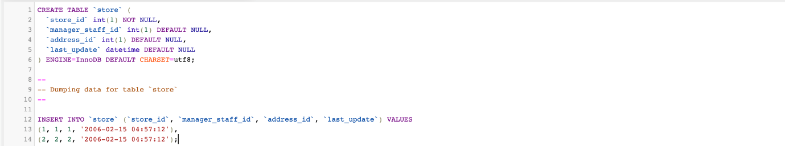

**TABLE CONSTRAINTS (FOREIGN KEYS)**

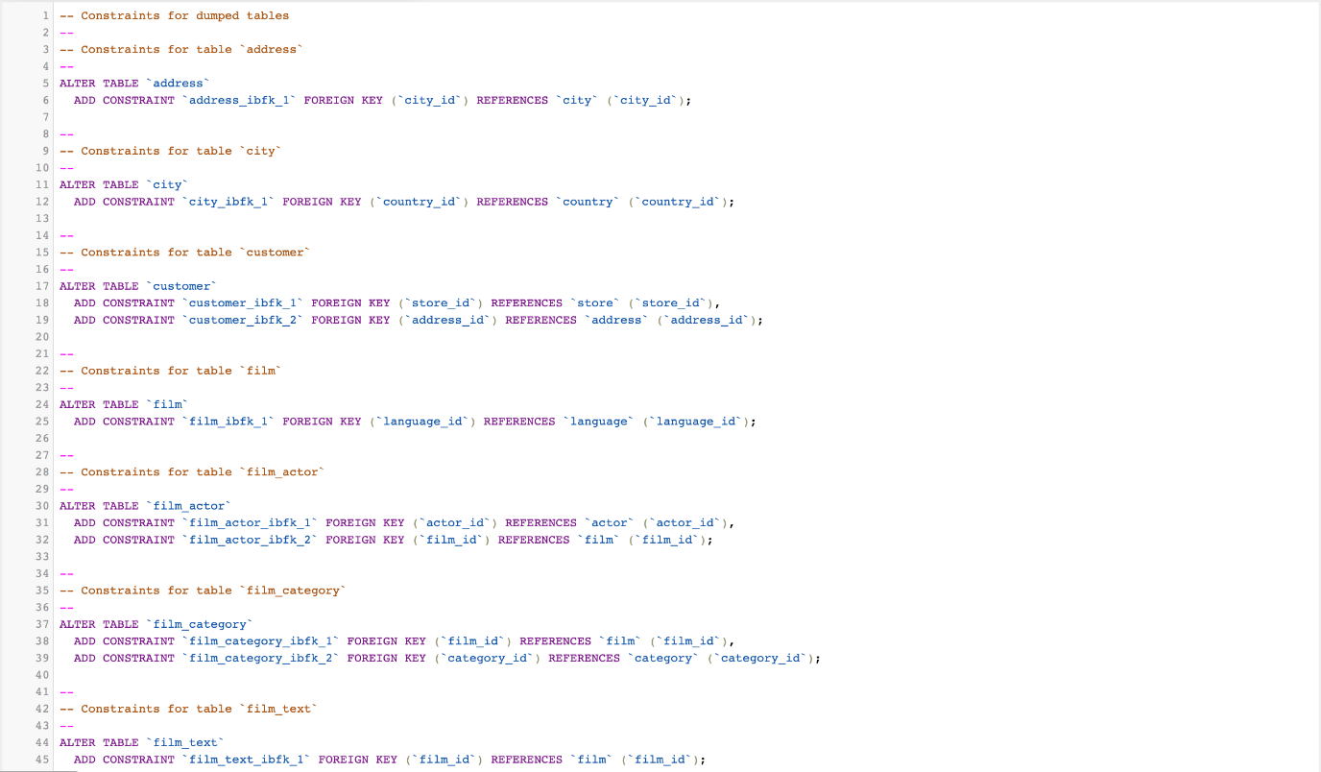

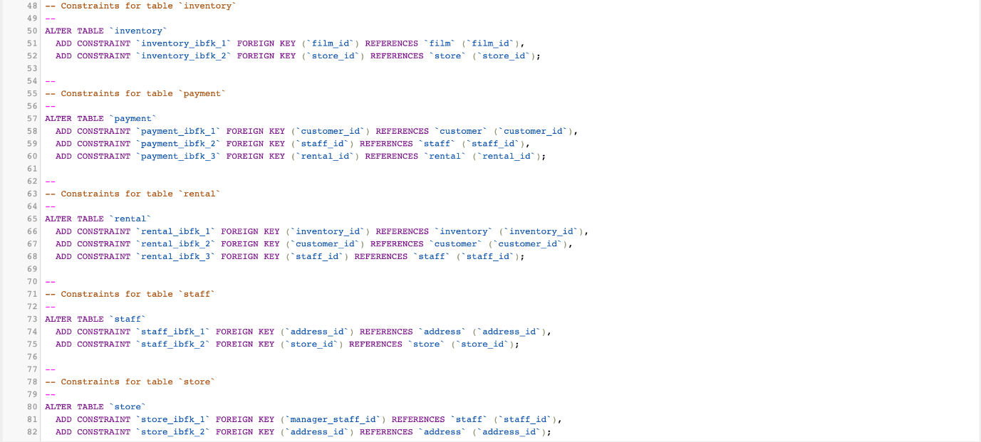

**TABLE INDEXES (PRIMARY KEYS/FOREIGN KEYS)**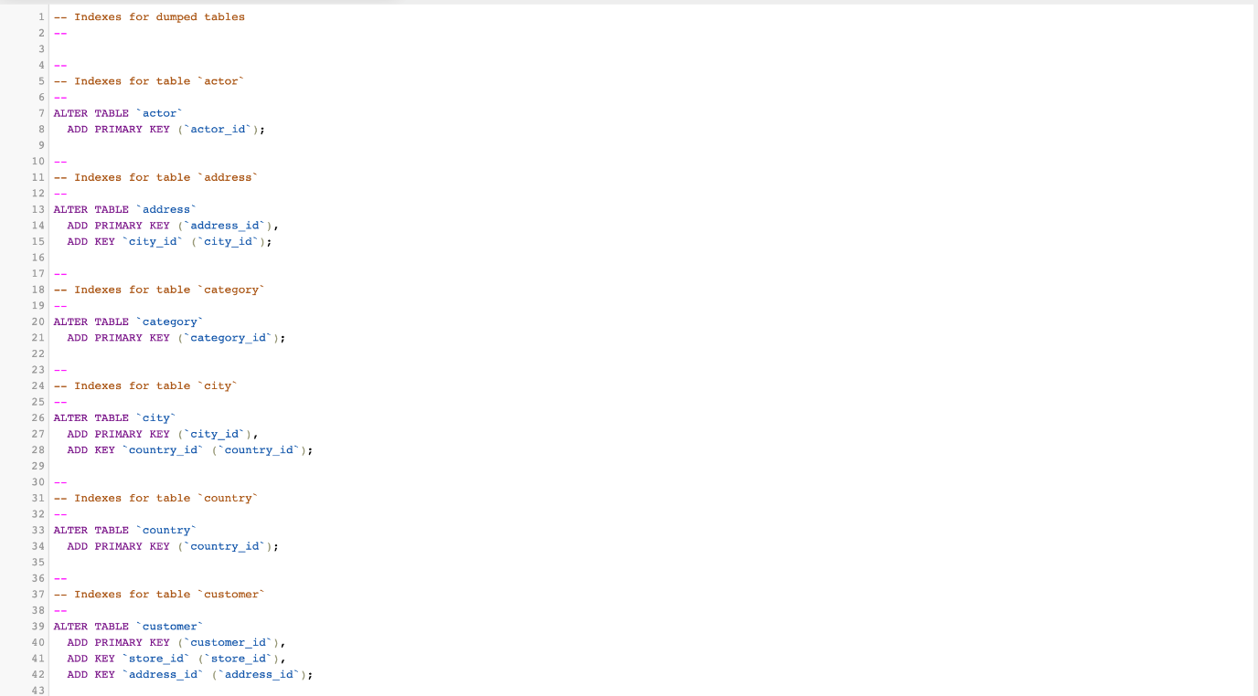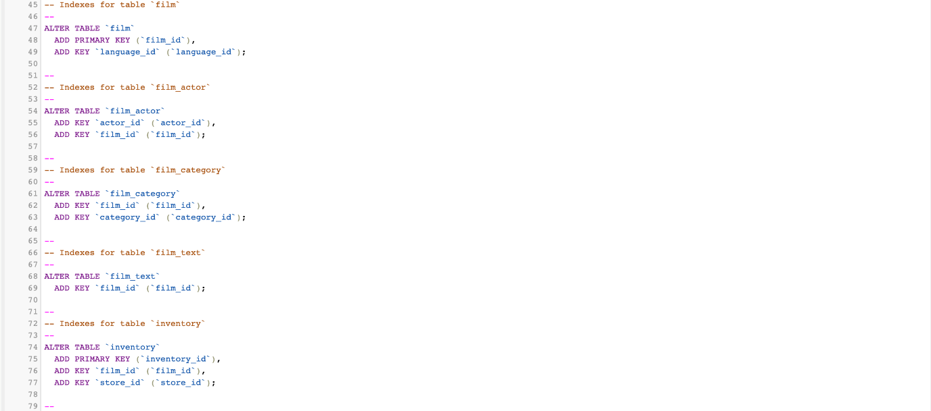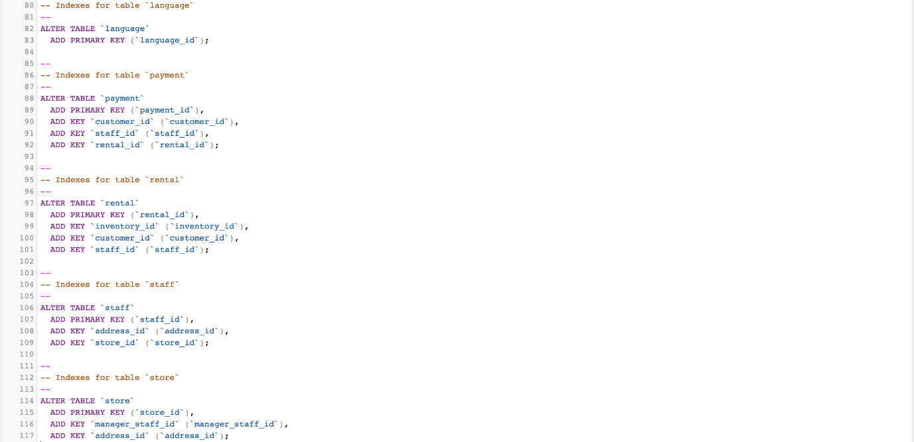

**TABLE STRUCTURES**

* **TABLE ‘ACTOR’**

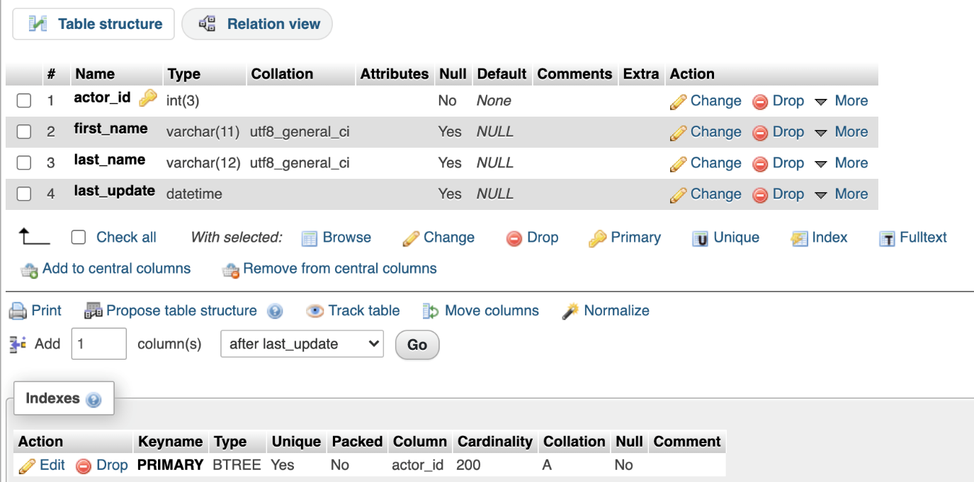

* **TABLE ‘ADDRESS’**

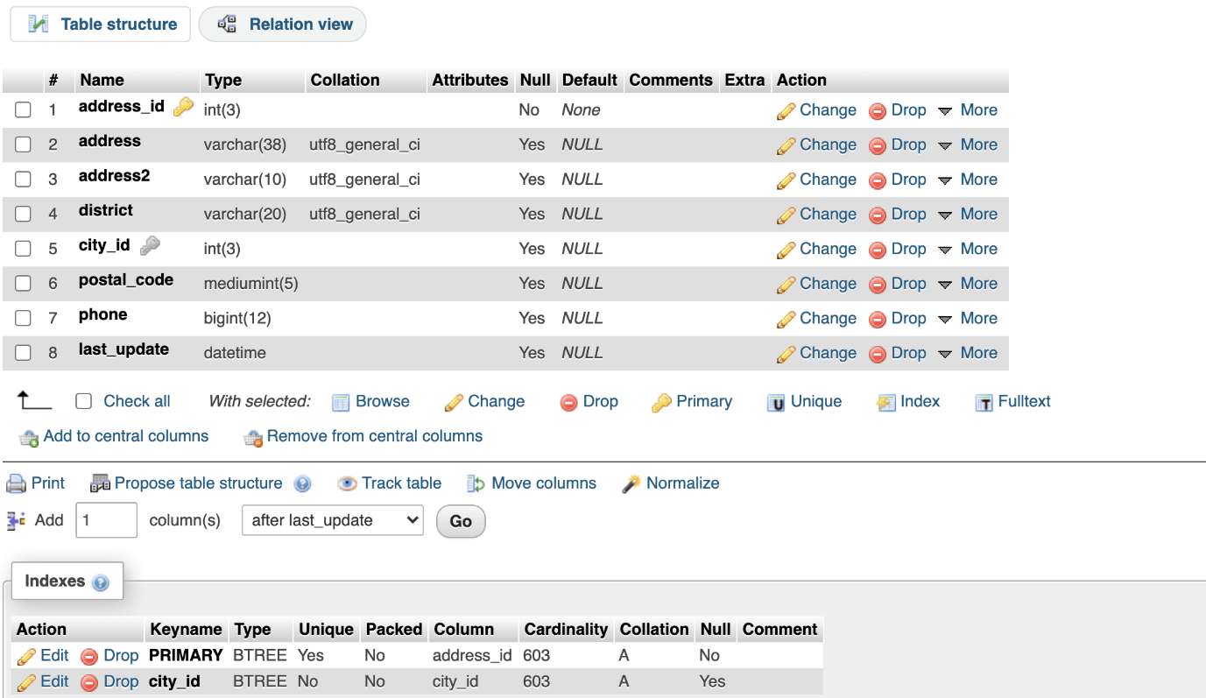

* **TABLE ‘CATEGORY’**

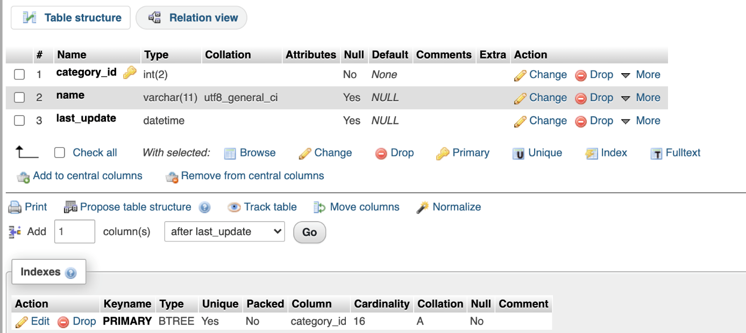

* **TABLE ‘CITY’**

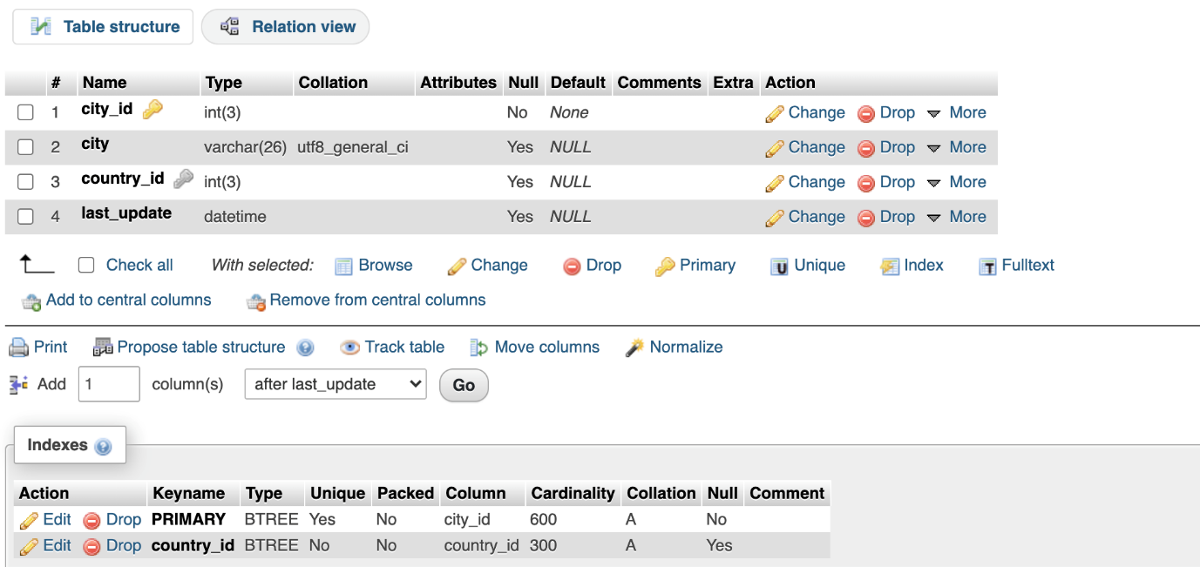

* **TABLE ‘COUNTRY’**

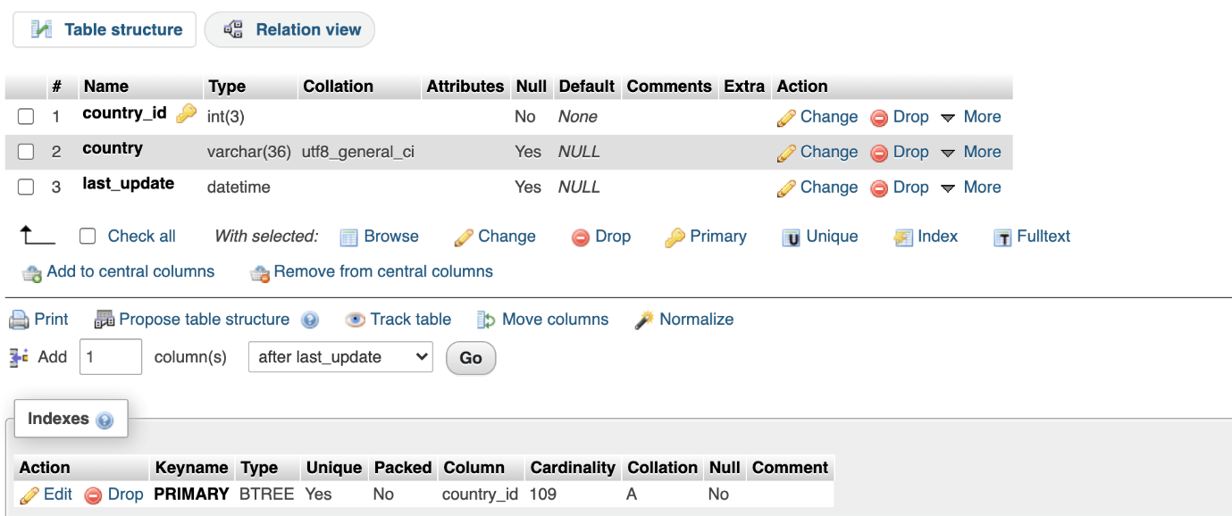

* **TABLE ‘CUSTOMER’**

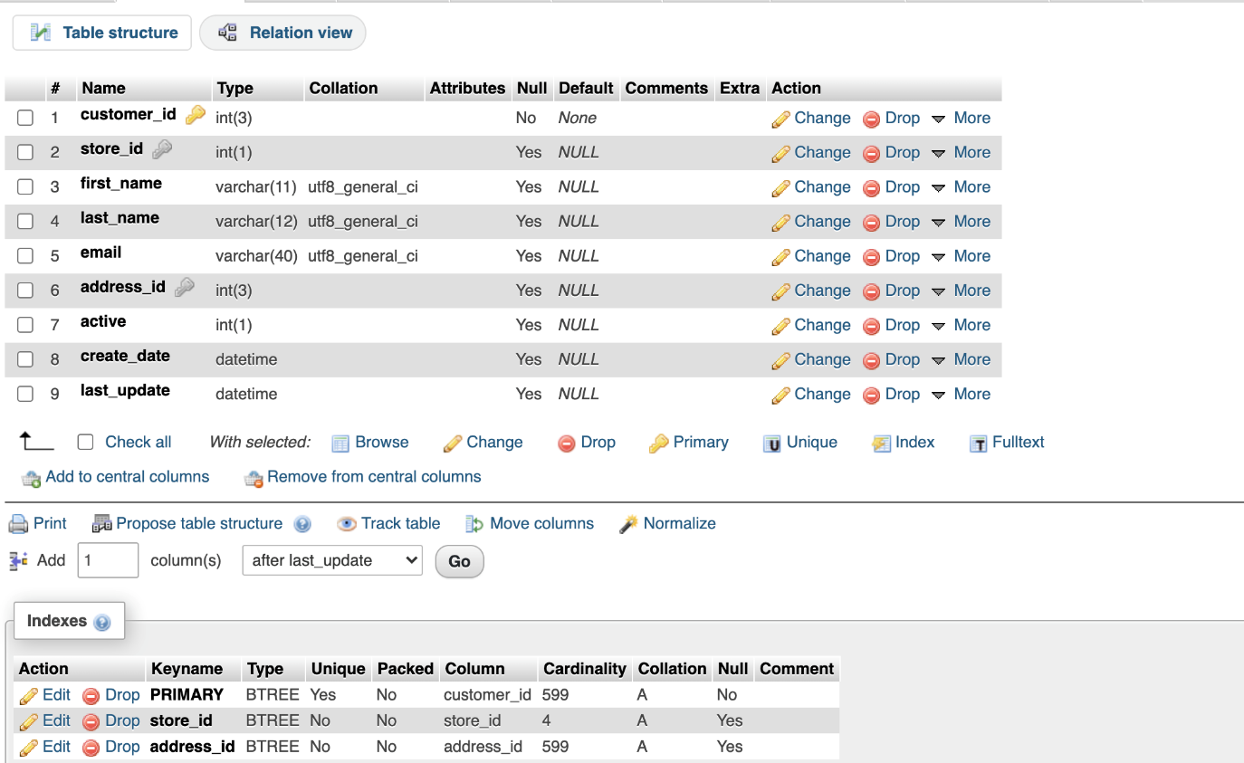

* **TABLE ‘FILM_ACTOR’**

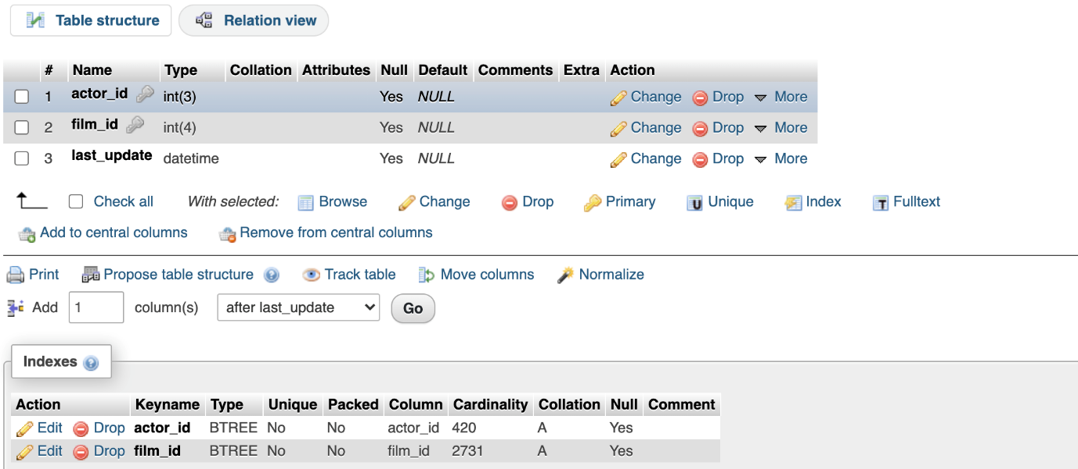

* **TABLE ‘FILM_CATEGORY’**

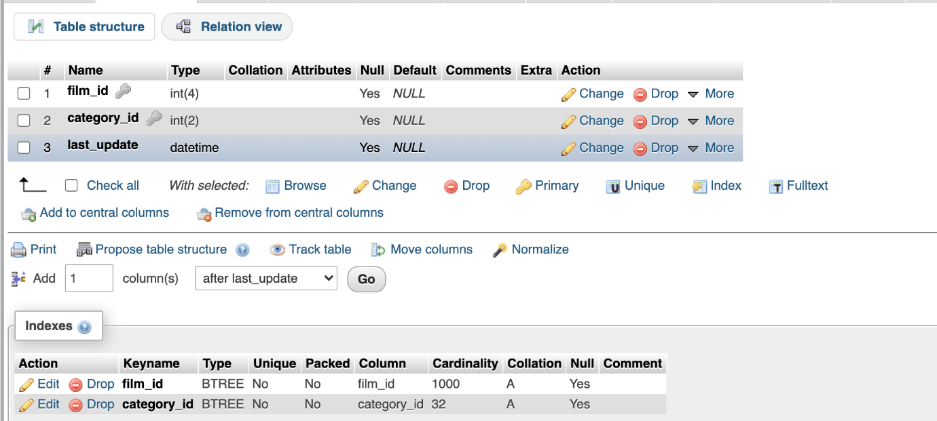

* **TABLE ‘FILM’**

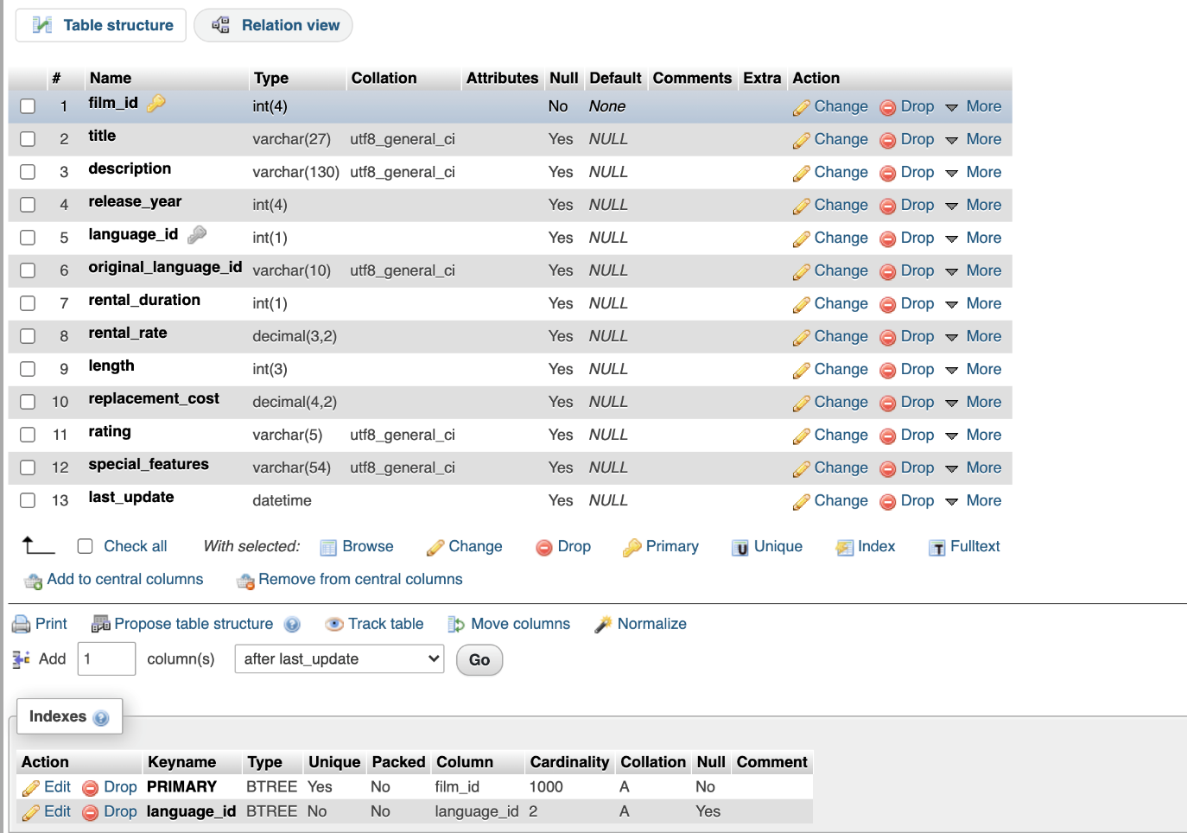

* **TABLE ‘FILM_TEXT’**

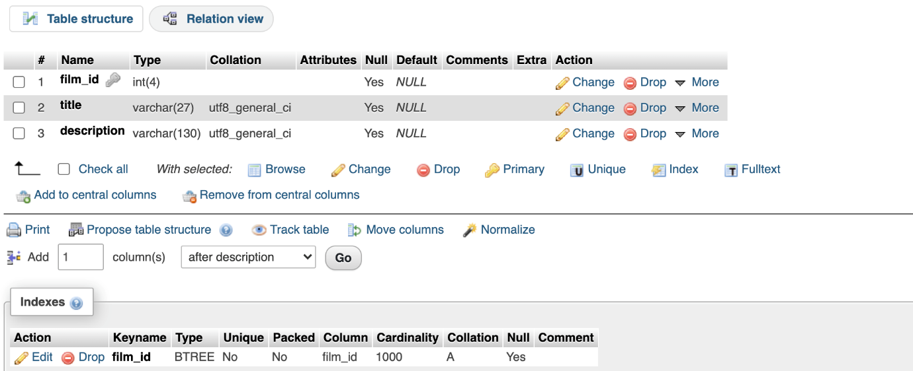

* **TABLE ‘INVENTORY’**

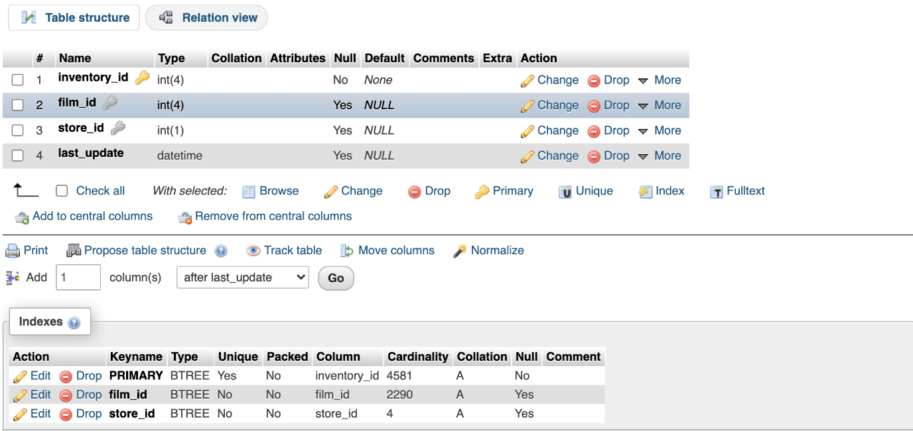

* **TABLE ‘LANGUAGE’**

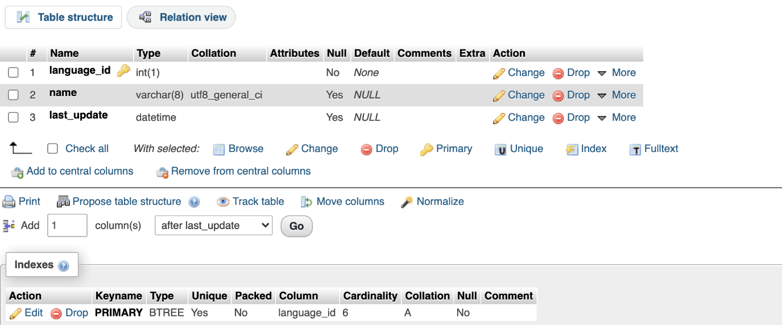

* **TABLE ‘PAYMENT’**

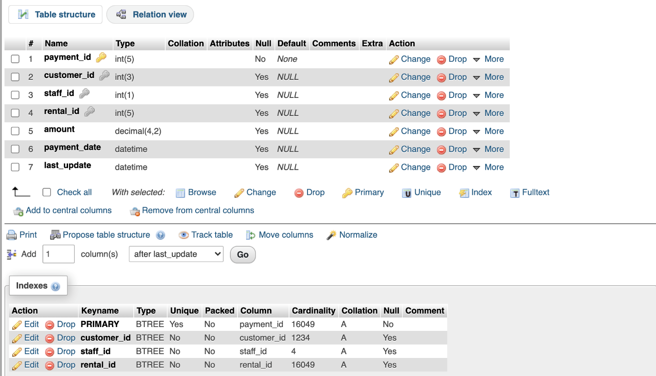

* **TABLE ‘RENTAL’**

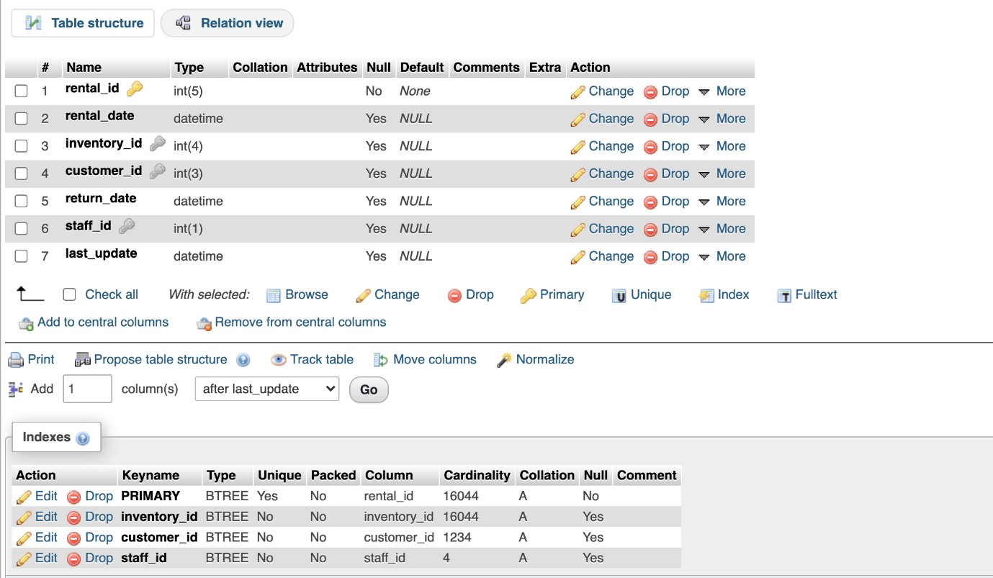

* **TABLE ‘STAFF’**

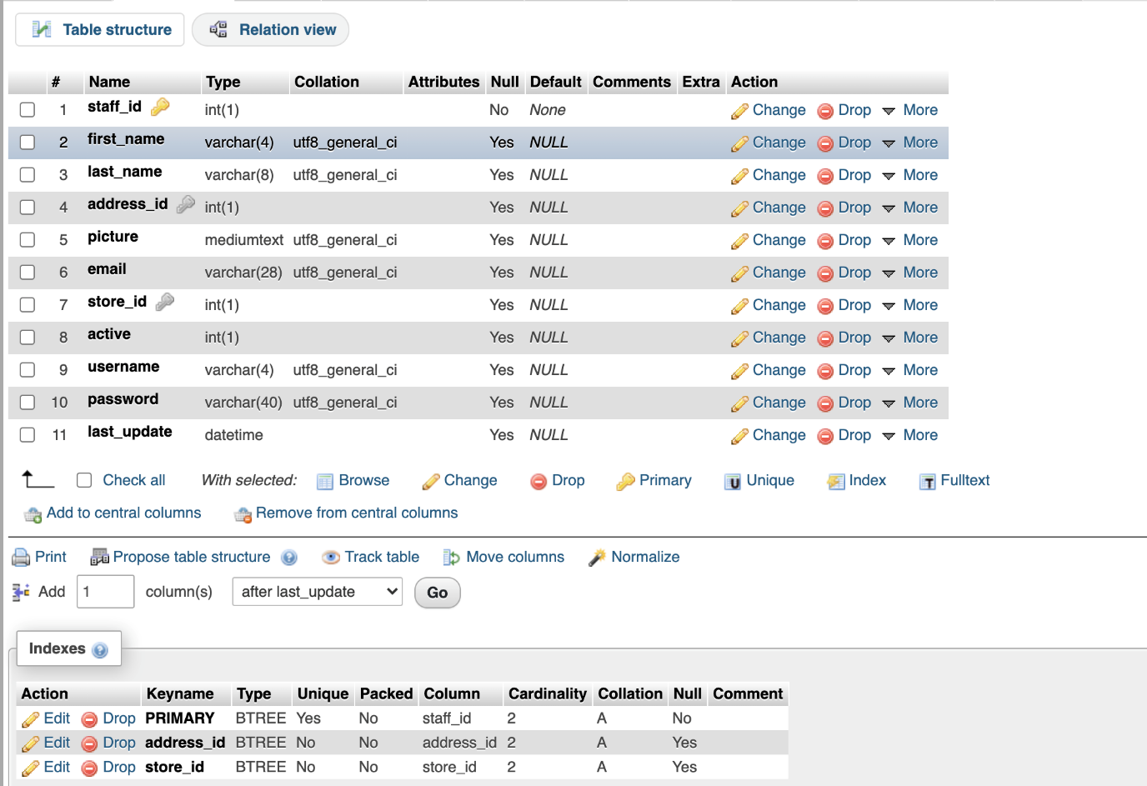

* **TABLE ‘STORE’**

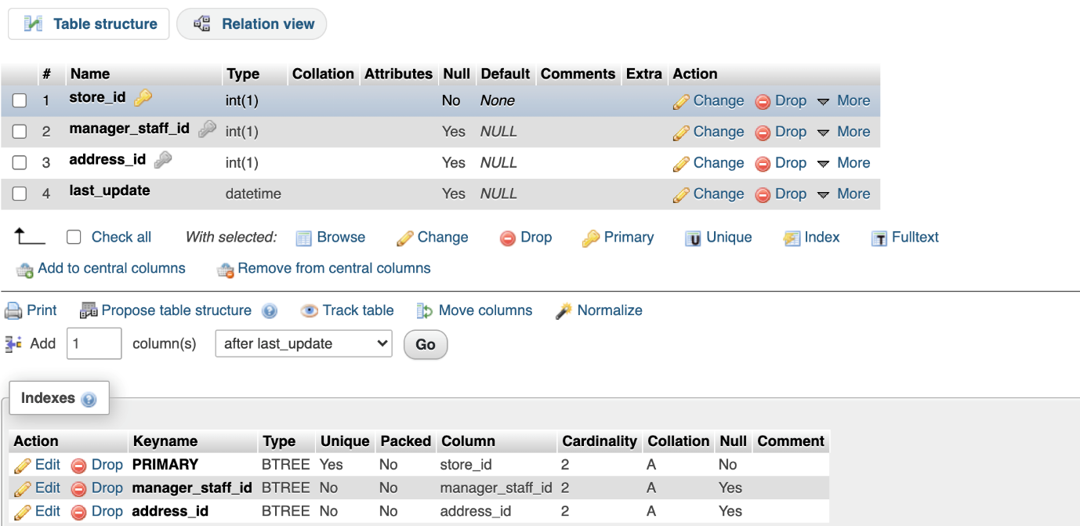

**INSERTION OF DATA (RESULT) / SELECTION**

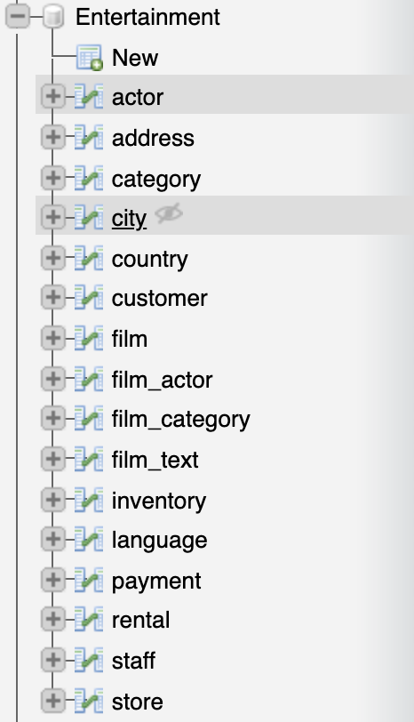

**TABLES OF DATABASE ‘ENTERTAINMENT’**

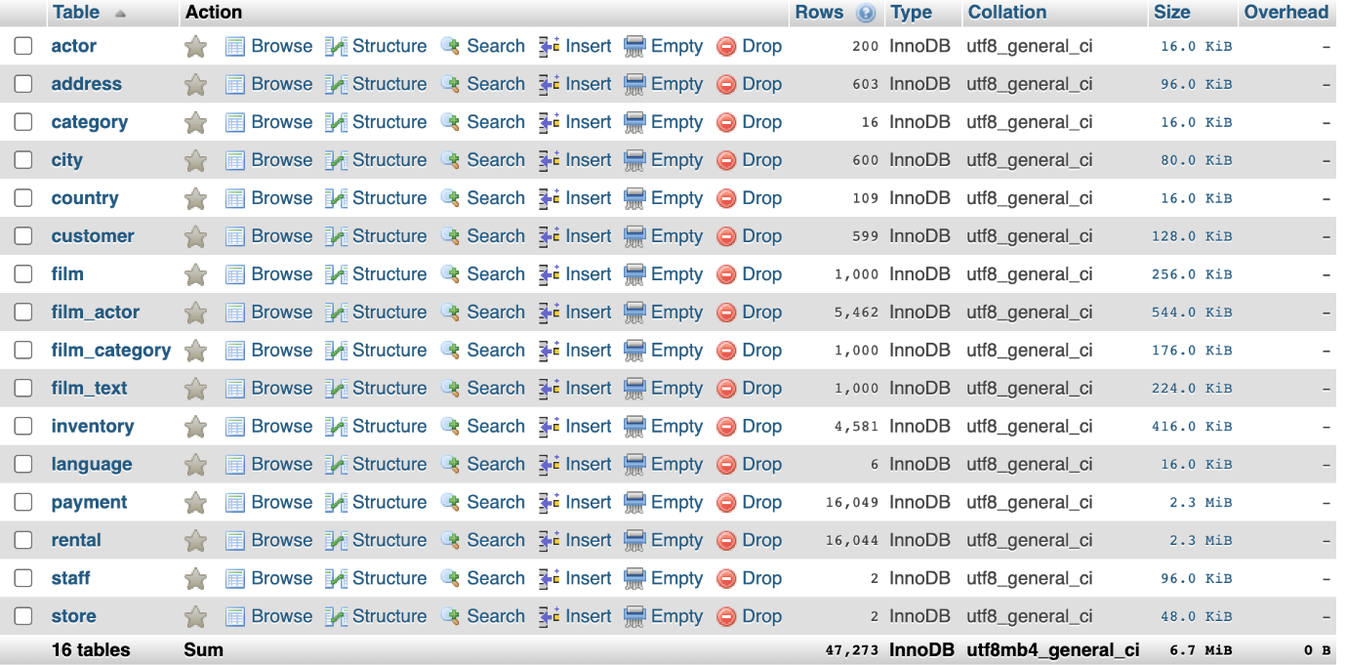

* **TABLE ‘ACTOR’**

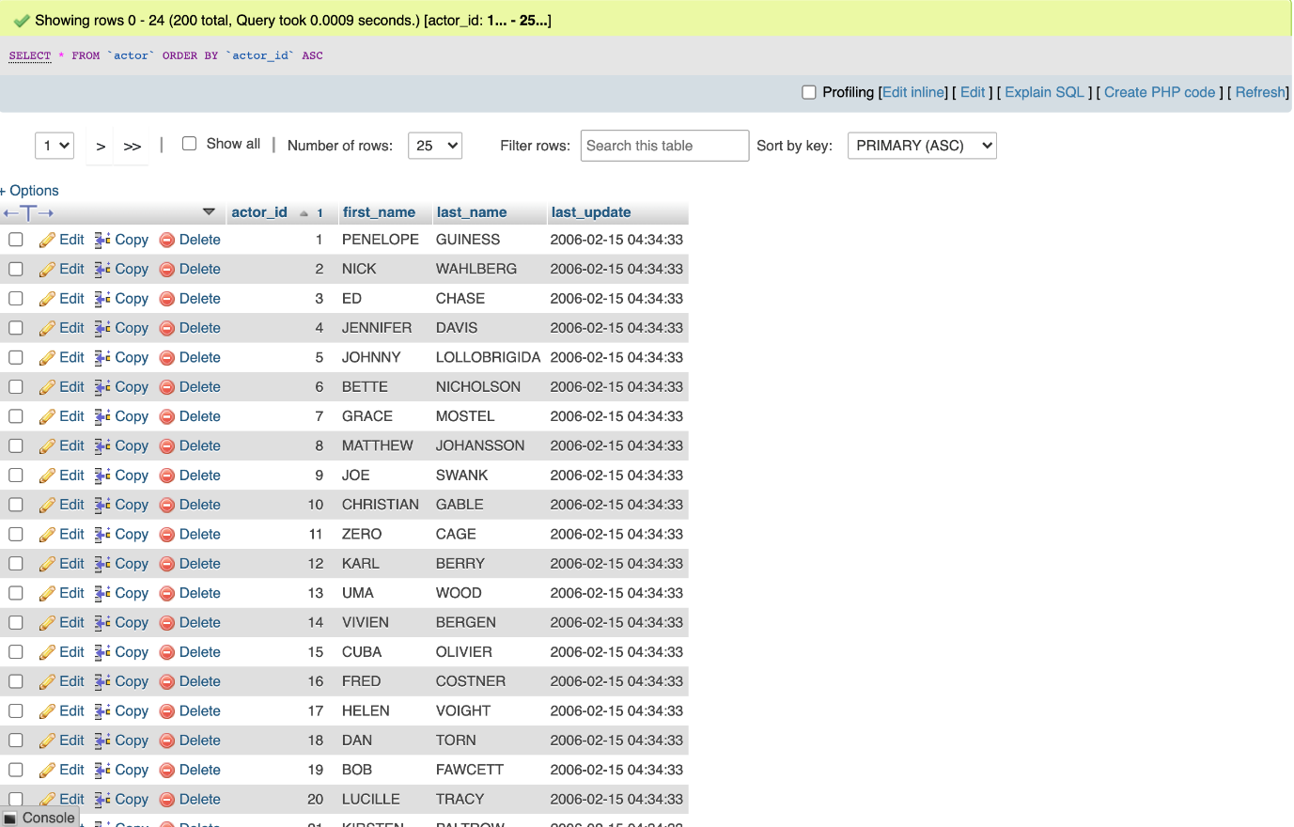

* **TABLE ‘ADDRESS’**

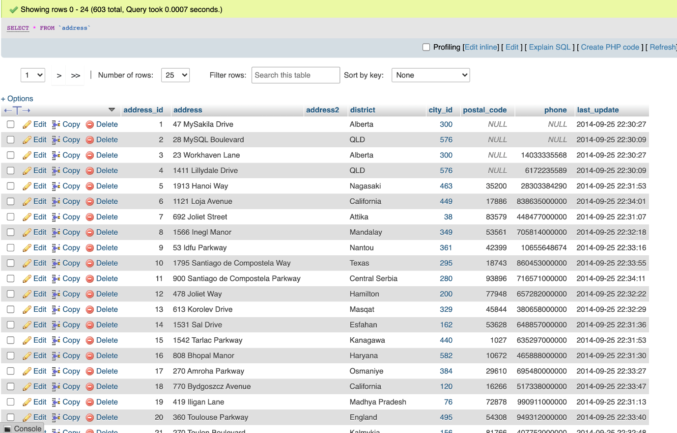

* **TABLE ‘CATEGORY’**

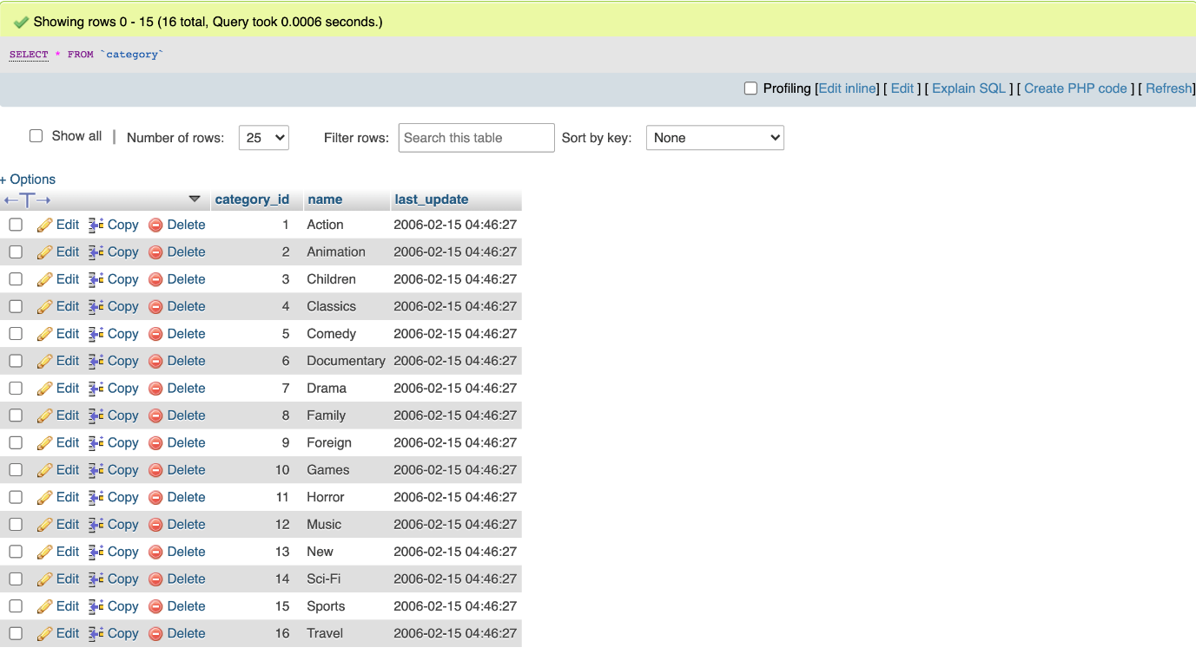

* **TABLE ‘CITY’**

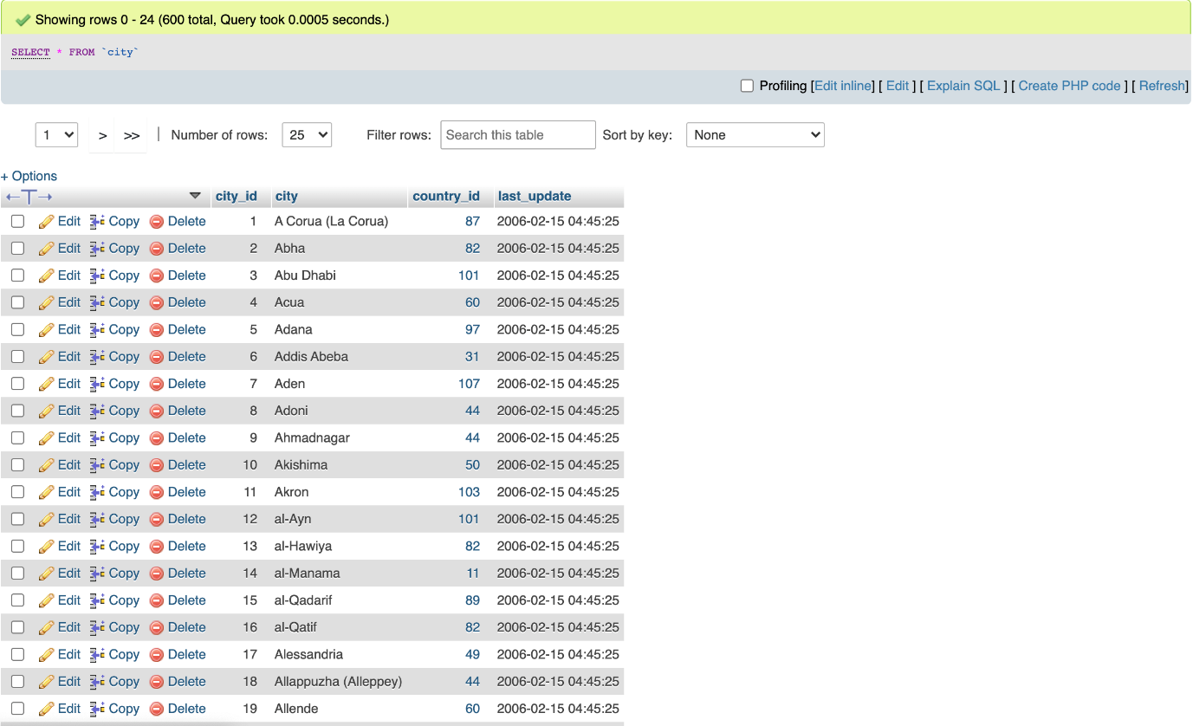

* **TABLE ‘COUNTRY’**

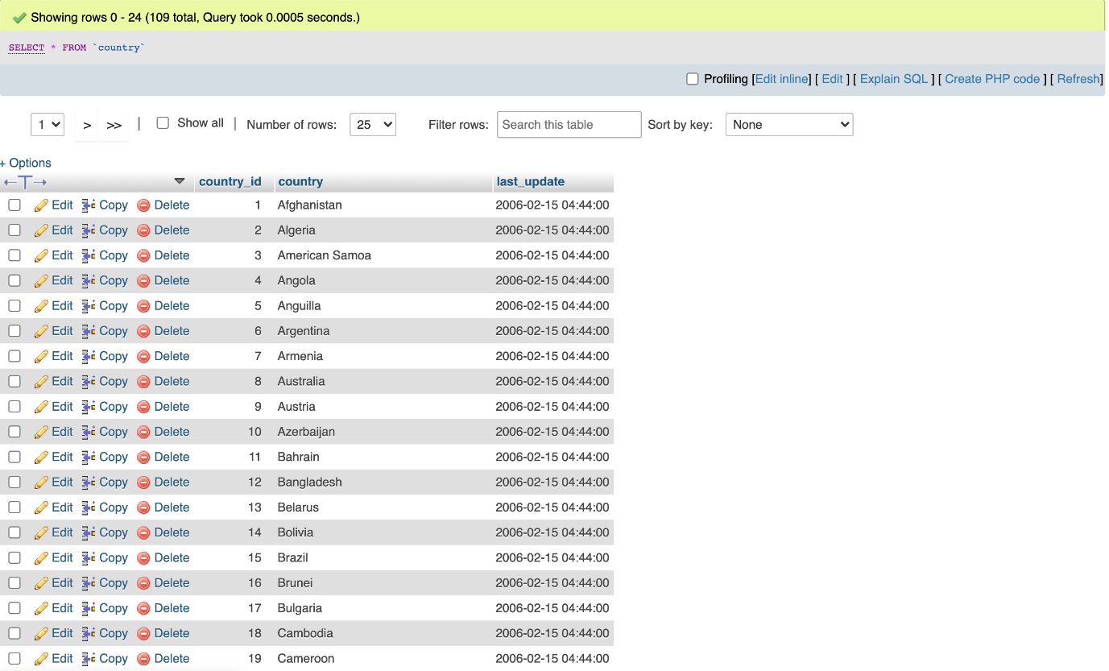

* **TABLE ‘CUSTOMER’**

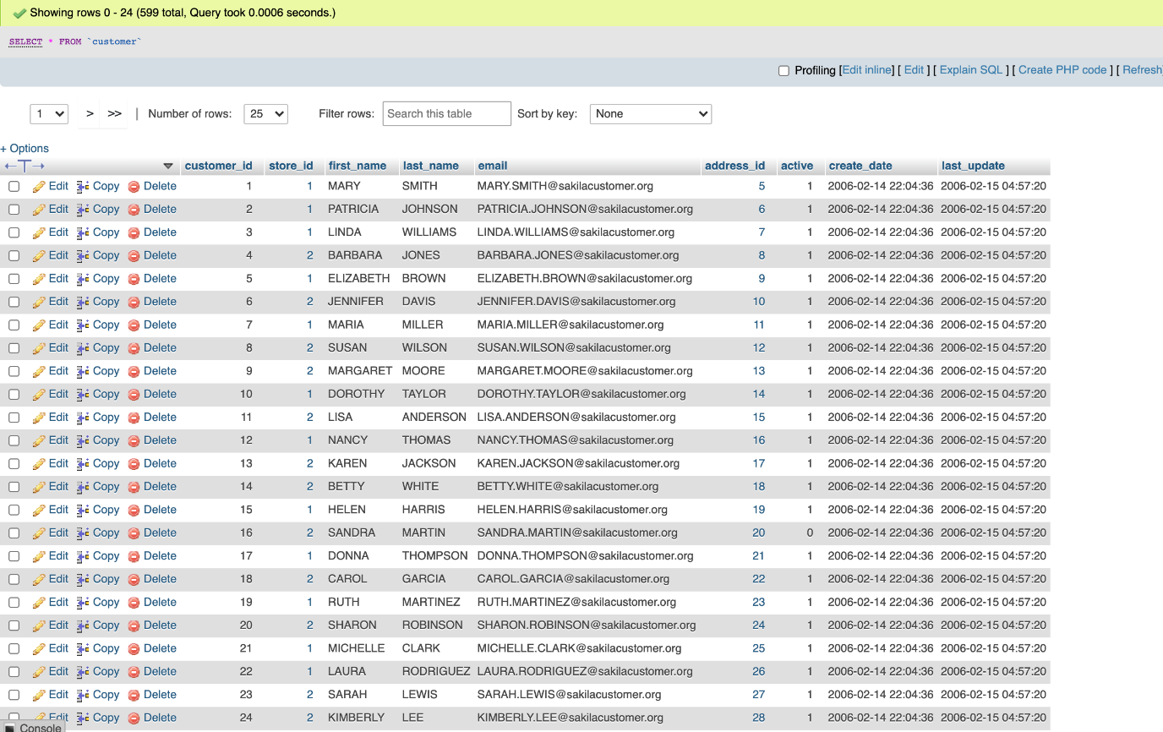

* **TABLE ‘FILM’**

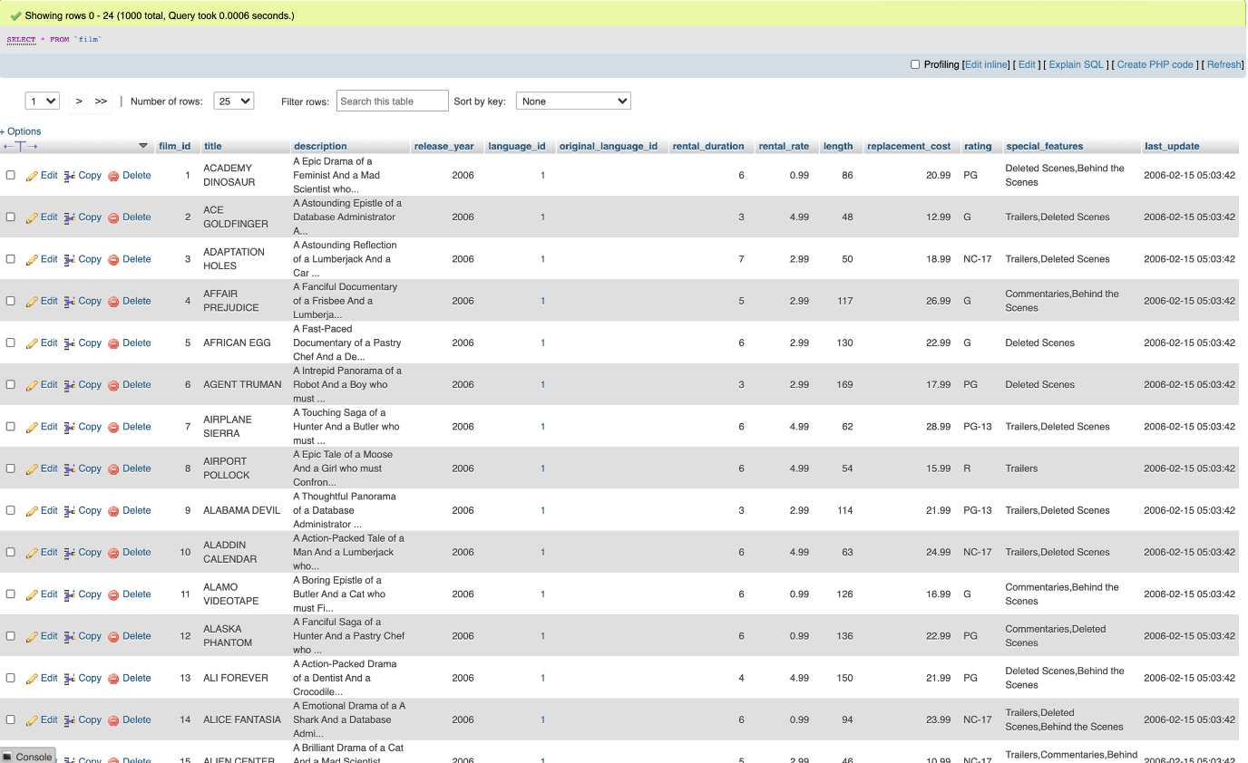

* **TABLE ‘FILM_ACTOR’**

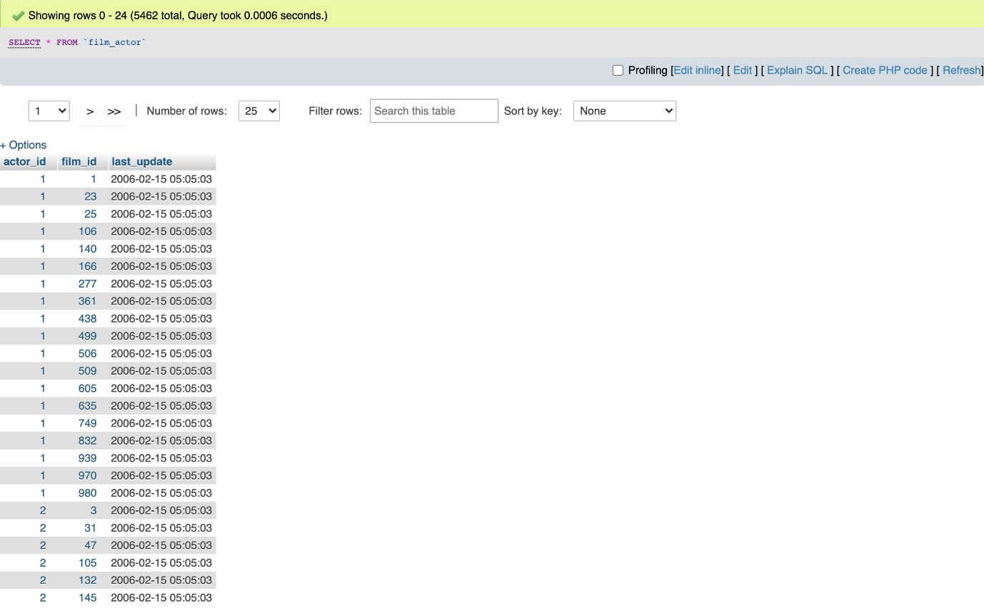

* **TABLE ‘FILM_CATEGORY’**

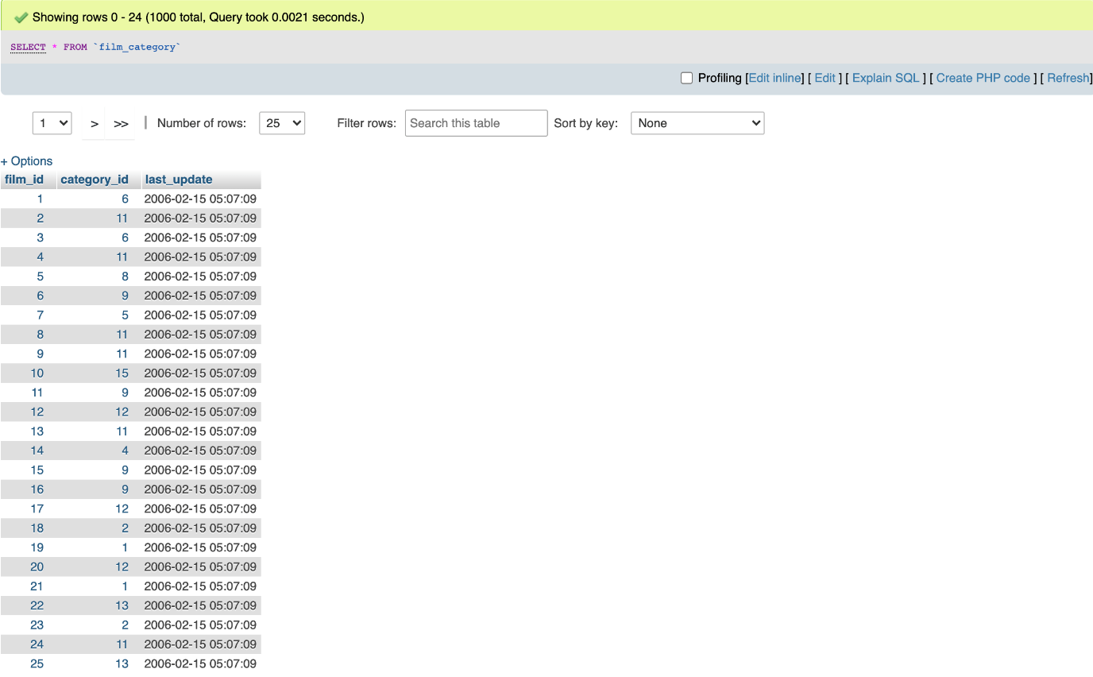

* **TABLE ‘FILM_TEXT’**

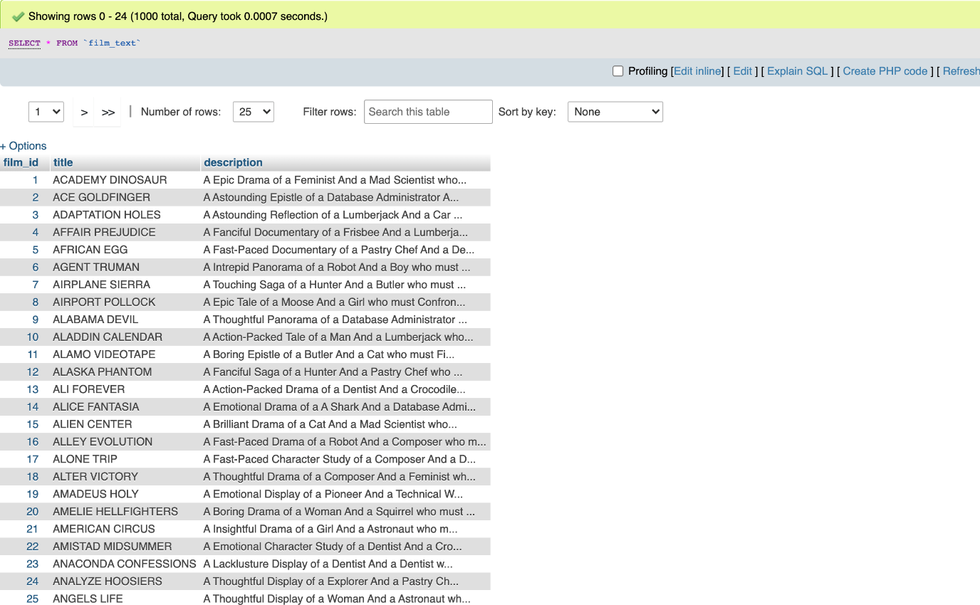

* **TABLE ‘INVENTORY’**

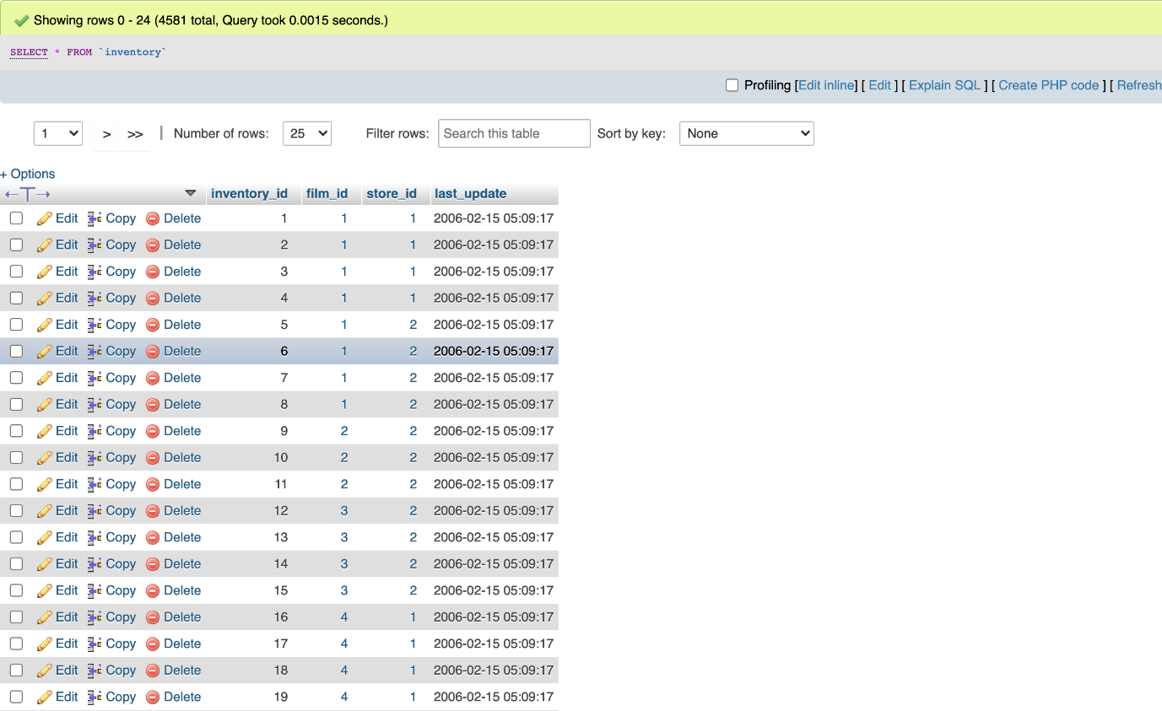

* **TABLE ‘LANGUAGE’**

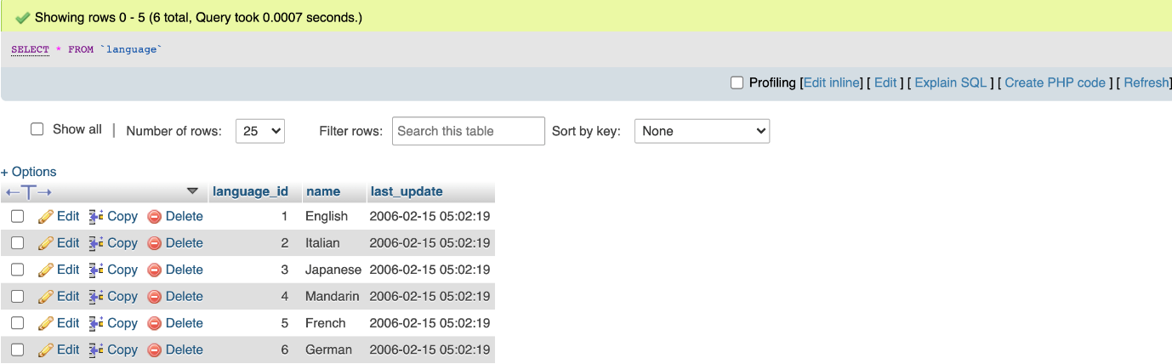

* **TABLE ‘PAYMENT’**

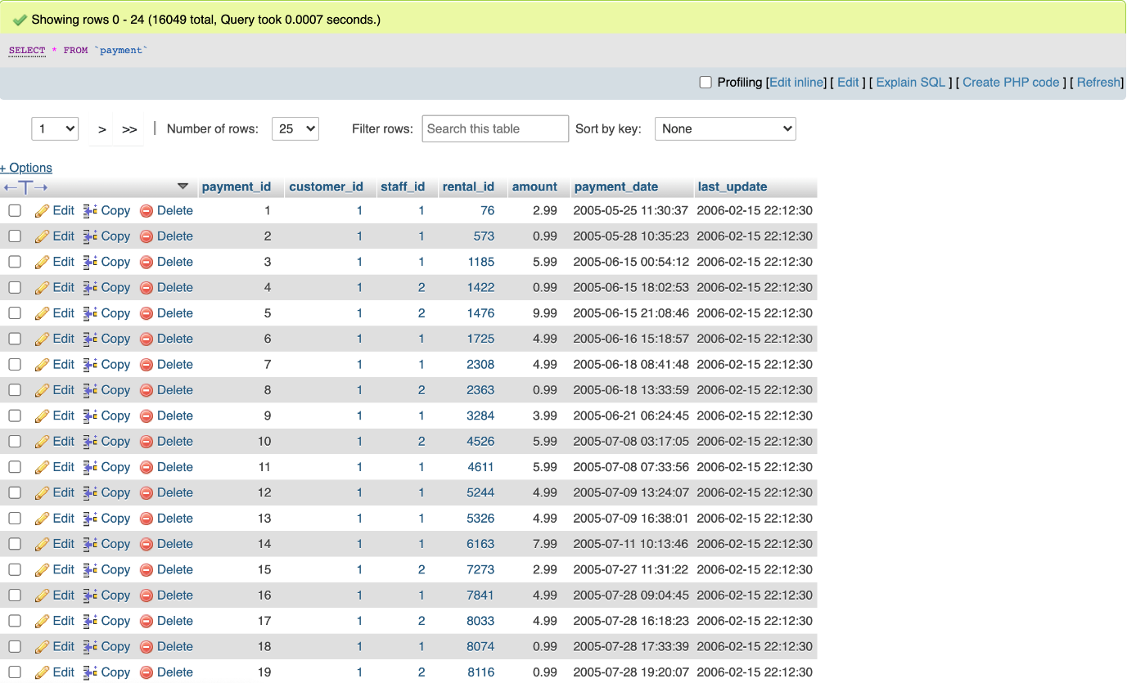

* **TABLE ‘RENTAL’**

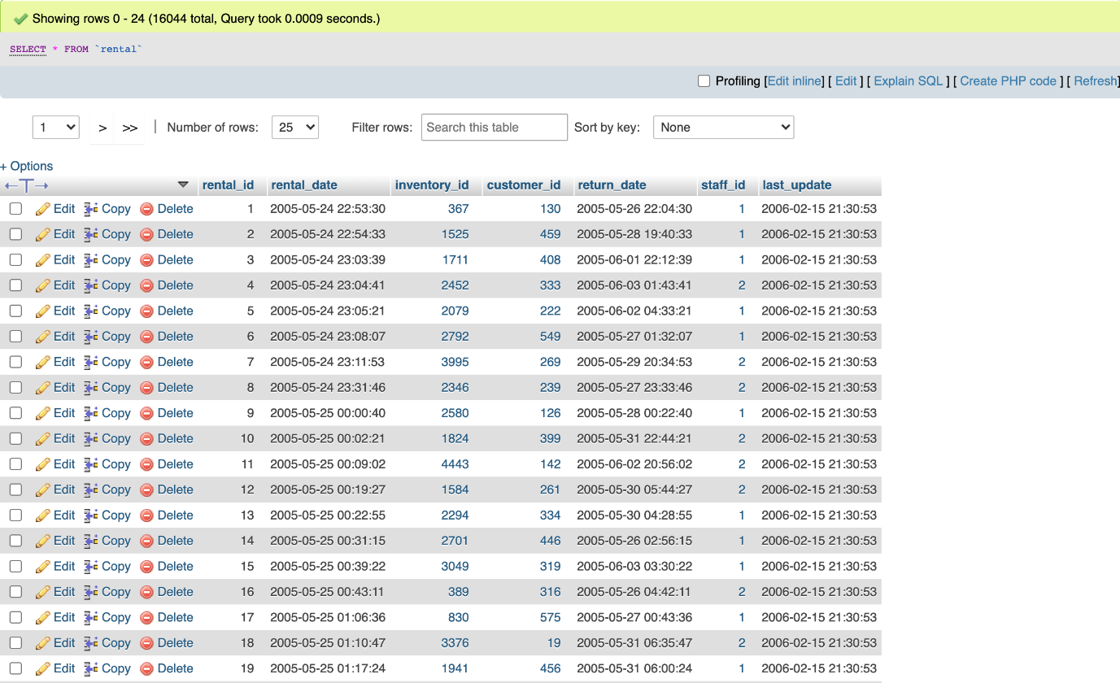

* **TABLE ‘STAFF’**

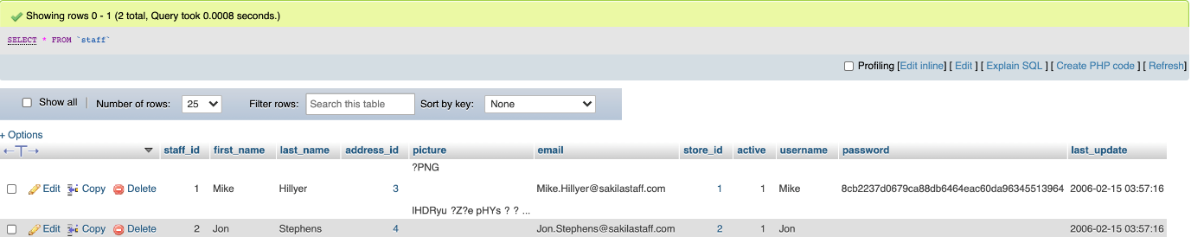

* **TABLE ‘STORE’**

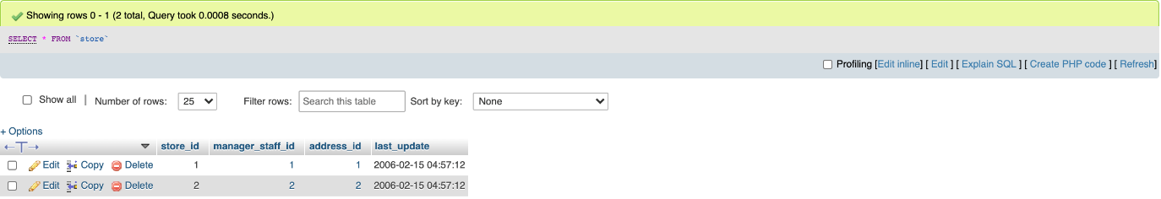

**ER DIAGRAM (AFTER NORMALIZATION)**

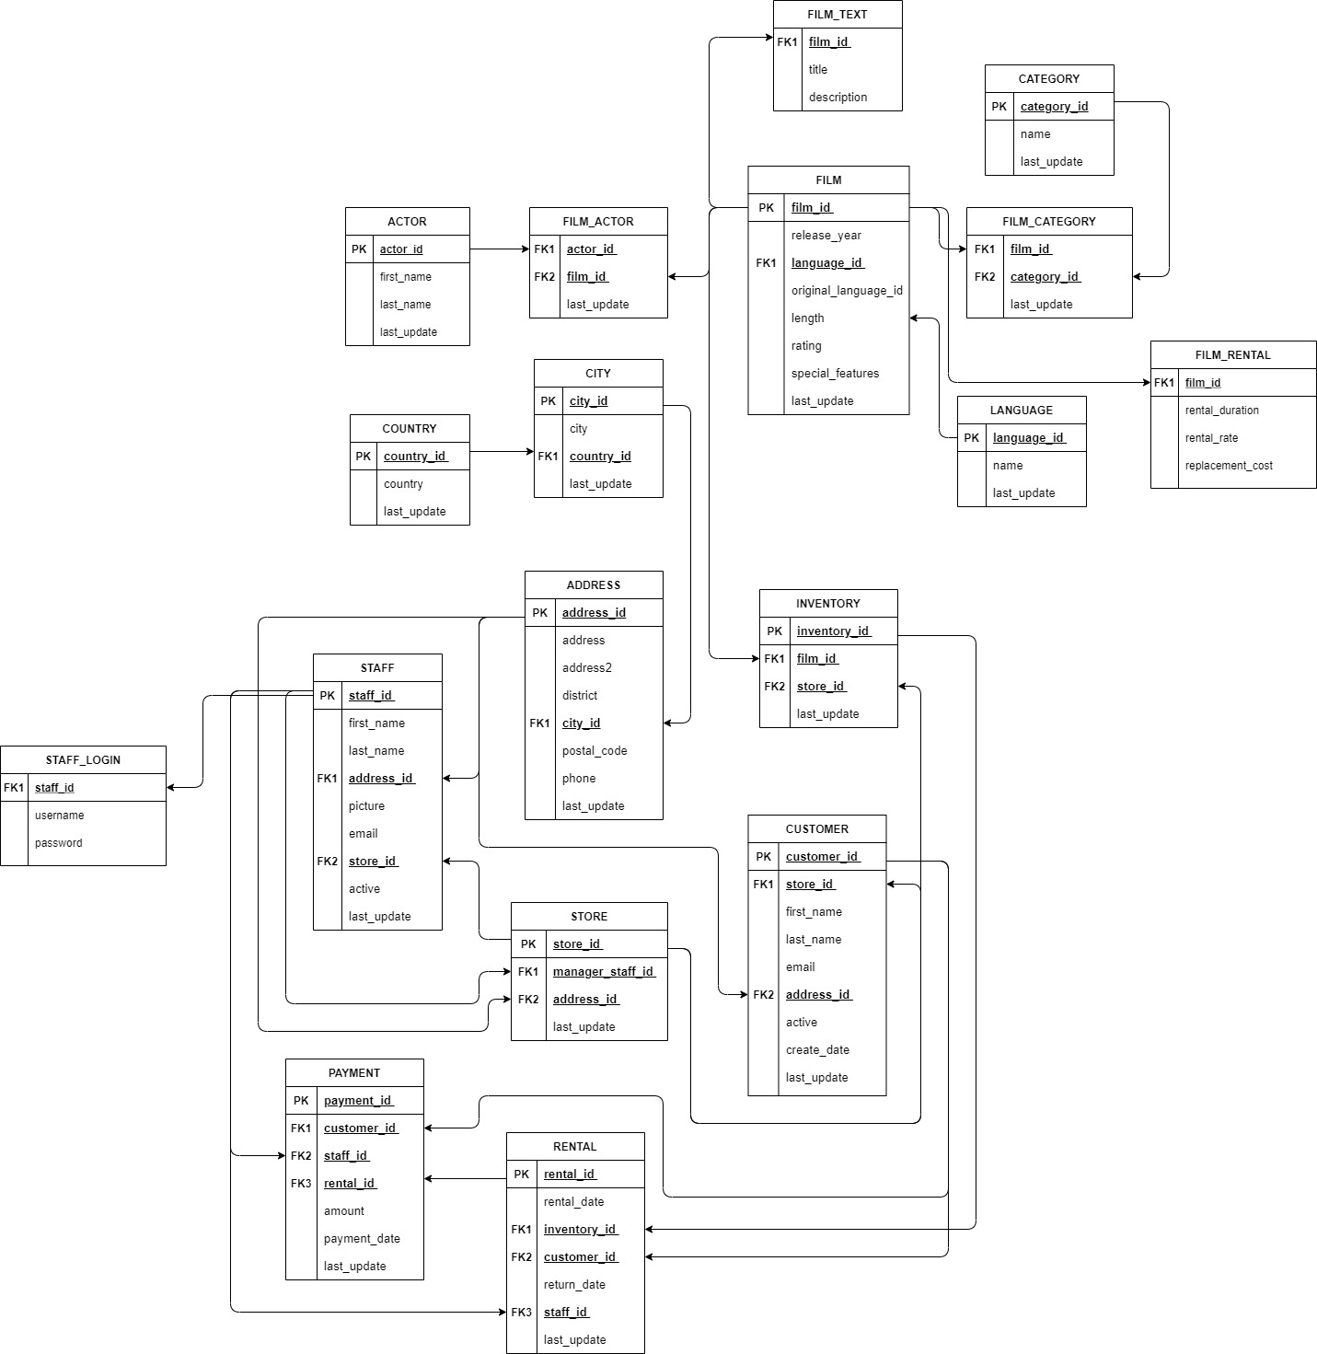

**TABLES AFFECTED BY NORMALIZATION**

* **TABLE ‘FILM’**

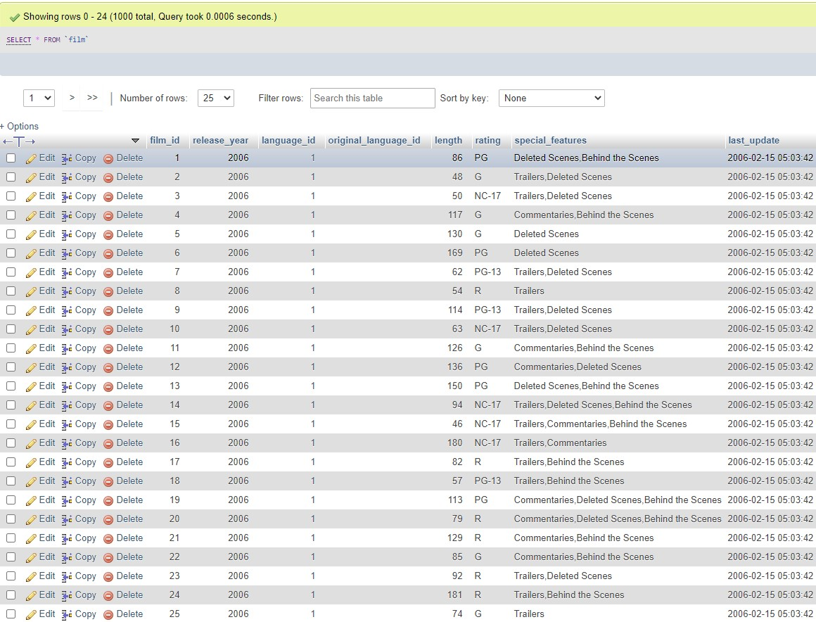

* **TABLE ‘FILM_RENTAL’**

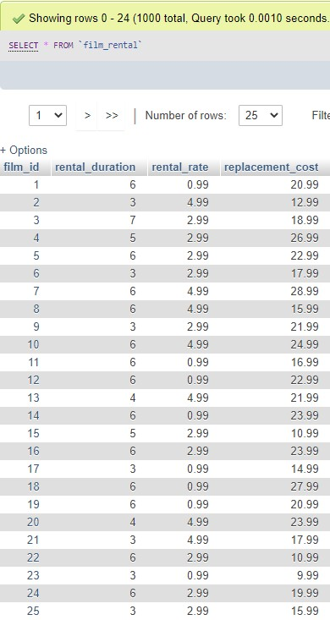

* **TABLE ‘STAFF’**

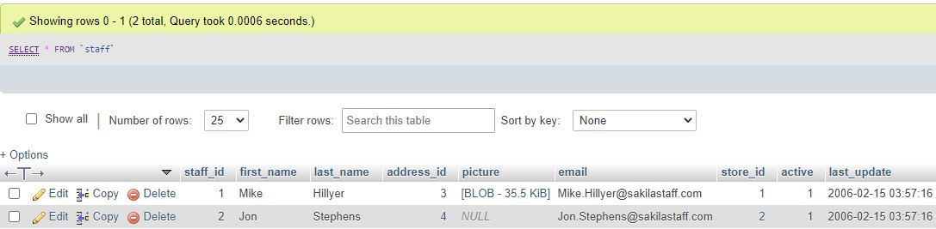

* **TABLE ‘STAFF_LOGIN’**

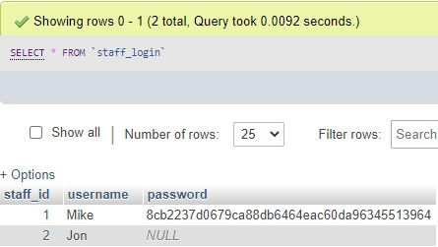

**TABLES AFFECTED BY NORMALIZATION (STRUCTURE)**

* **TABLE ‘FILM’**

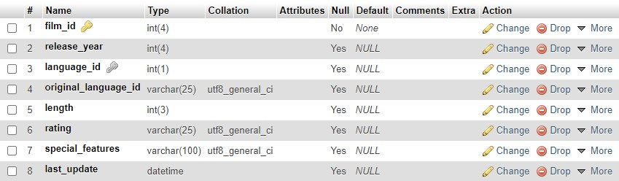

* **TABLE ‘FILM_TEXT’**

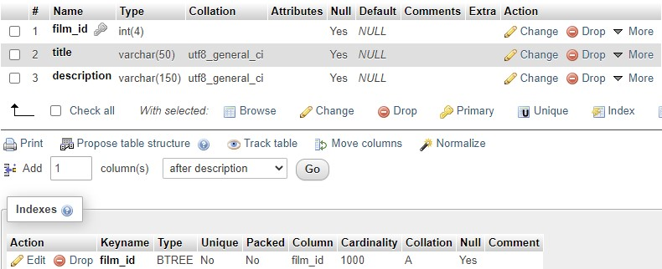

* **TABLE ‘STAFF’**

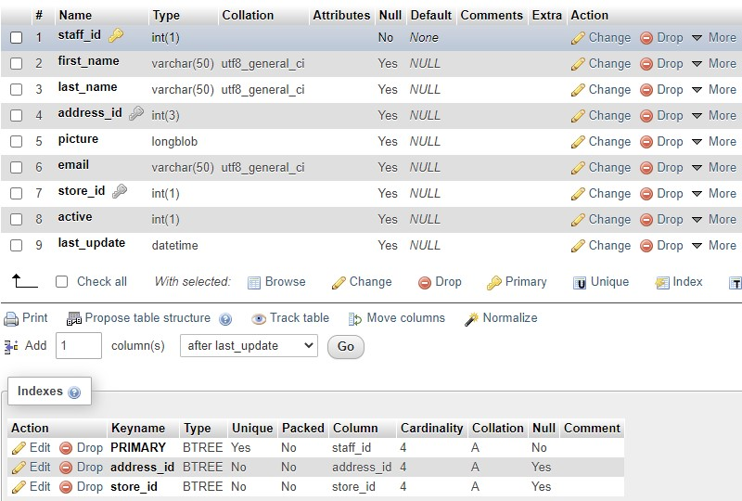

* **TABLE ‘STAFF_LOGIN’**

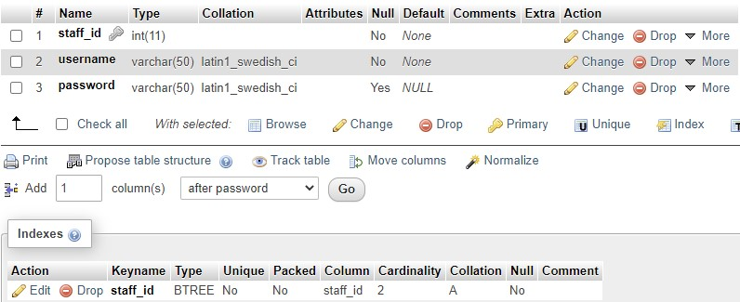

**INSERT (AFTER NORMALIZATION)**

* **TABLE ‘STAFF’**



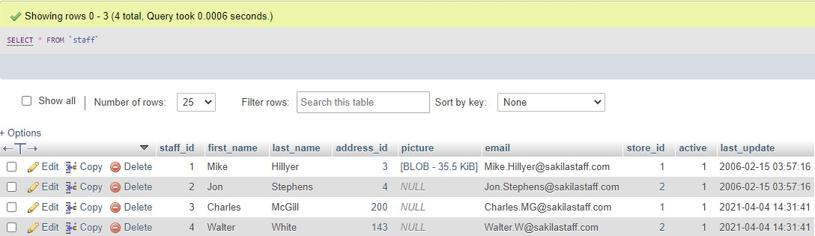

* **TABLE ‘STAFF_LOGIN’**

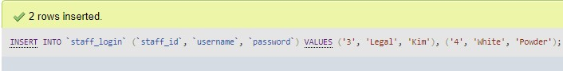

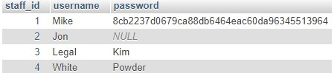

**DELETE (AFTER NORMALIZATION)**

* **TABLE ‘STAFF’**

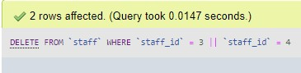

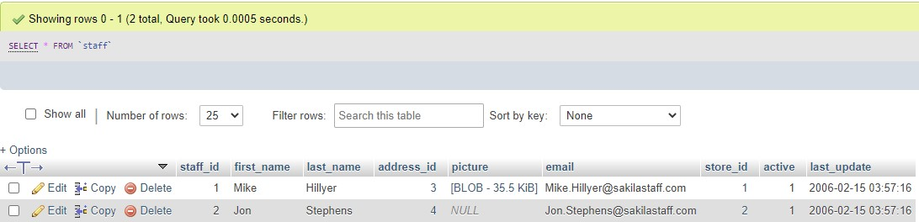

* **TABLE ‘STAFF_LOGIN’**

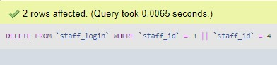

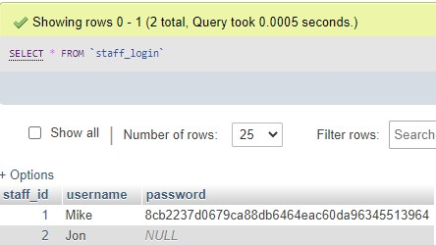

**UPDATE (AFTER NORMALIZATION)**

* **TABLE ‘STAFF_LOGIN’**

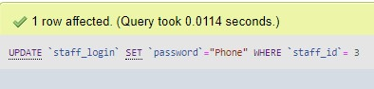

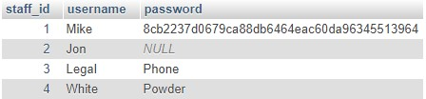

**SELECTION (Based On Original Database With WHERE)**

* **TABLE ‘CUSTOMER’**

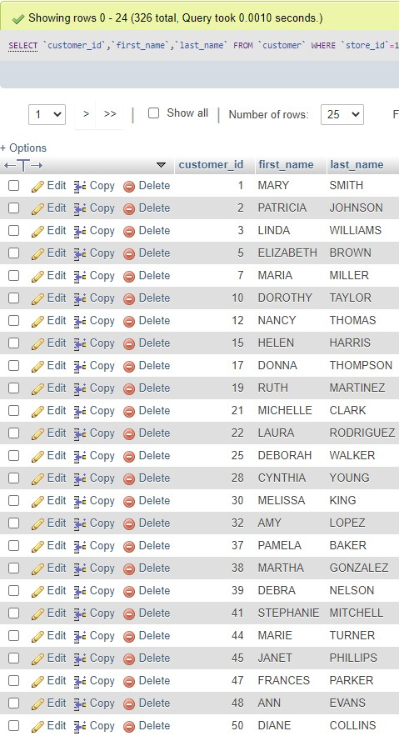

* **TABLE ‘FILM’**

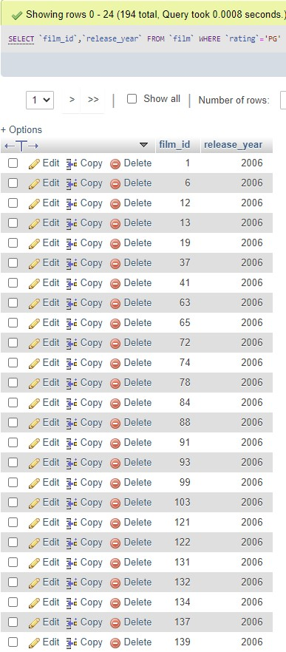

* **TABLE ‘FILM_CATEGORY’**

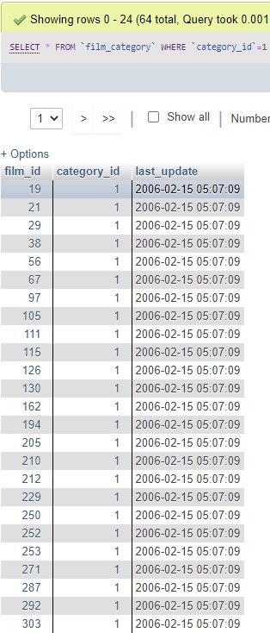

* **TABLE ‘INVENTORY’**

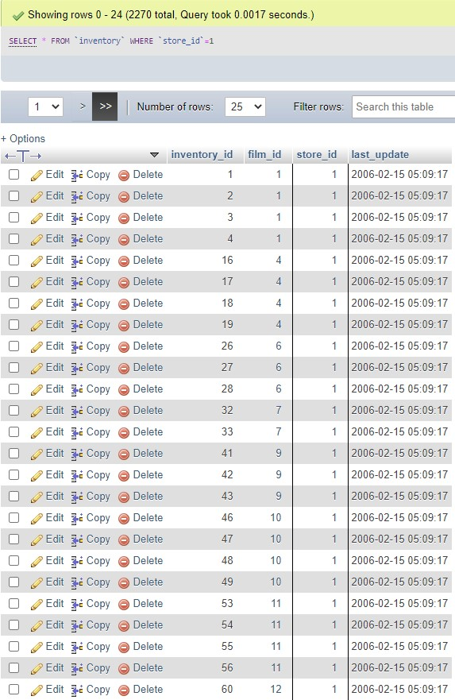

* **TABLE ‘PAYMENT’**

